CENTRAL LYON
HIGH SCHOOL

Course Description Handbook

2026-2027

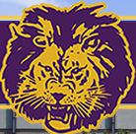

Freshmen Sophomores

Juniors Seniors

TABLE OF CONTENTS

Table of Contents 2

Required Courses for Graduation 3-7

Multicultural - Non-Sexist 8

Requirements for Graduation 9-12

Language Arts 14-16

Math 17-19

Sciences 20-22

Social Studies 23-24

Business Education Program 25-26

Computer/Office Program 26-27

Foreign Language 27-28

Family and Consumer Sciences 28-29

Industrial Technology 30-33

Vocational Agriculture 33-35

Art Education 35-36

Work Based Learning 37-39

Health Education________________________________ 39

Drivers Education 40

Music Education 40

Physical Education 41

Concurrent Enrollment Classes Requirements__ 42

Concurrent Enrollment Courses____________________ 42-52
FOUR YEAR PLANNING CALENDAR
Time management is an important skill that needs to be developed early. Dividing major tasks
into small steps makes it easier to reach major goals. A college education and career goals are major goals much too important to leave to chance. The following calendar is a four-year high school guide indicating key checkpoints. Skim the entire list; then refer to appropriate sections regularly.

Take responsibility for your own future. Investigate options, deadlines, and follow through. Parents, teachers, the counselor and the principal can assist, but responsibility for action is yours!

FRESHMAN YEAR
- Select high school courses carefully. Choose courses that provide a solid academic foundation
and increase your abilities in reading, writing, speaking, math, and higher order thinking skills.
- Select your career focus based on your developing interests and academic strengths at this time.
- Resolve to take control of your life and develop skills that will lead to self-discipline, independence, and lifelong learning success.
- Organize a file system or scrapbook to maintain accurate records of accomplishments. Keep report cards, standardized tests scores, compositions, and special awards of recognition.
- Be prepared to explain your ideas and plans to your counselor during the spring scheduling conference. Listen to information and accept encouragement. Begin to build the ideas and dreams into reality.
- Read magazine articles and books that give information about college preparation.
- Begin a reading program. Carefully choose the books that you read and keep a record. Check with your English teacher for suggestions.
- Volunteer for community service projects.
- Get involved in high school. Become a member of at least one extracurricular activity each semester. Keep an accurate list of all the activities you are involved in. This will come in handy as a senior.

SOPHOMORE YEAR
- Enroll in challenging academic courses that will allow flexibility as interests evolve. Investigate the Advanced Placement courses at CLHS.
- Become more active in school organizations. Offer to serve on committees and become an active member.
- Talk to your counselor about your interests to help you identify possible career choices.
- Maintain your volunteer activities. Watch for opportunities for leadership.
- Continue to read as much as possible.
- Take the PreACT test and pay careful attention to your results.
- Begin checking out college or technical school requirements before choosing junior classes. The counseling office has several catalogs you may use.
- Summer-work at a paying job if you can find one. Begin saving as much as possible for your future education.
- Revise your career focus as needed.

JUNIOR YEAR
September – January
- Send for current catalogs and other literature of several selected schools.
- Investigate colleges that offer training in your area of interest.
- Use You Science online computer program to gather information about colleges.
- Investigate career materials and post-secondary opportunities through the media center.
October
- Take the PSAT to be considered for a National Merit Scholarship and other awards and as practice for college entrance exams. Check with the counseling office as to where and when the test will be given. Take the practice test which is included in the registration materials
January-February
- Plan your senior program of studies very carefully with your counselor and parents. The catalogs from the colleges of your choice will indicate courses required and recommended for admission. Begin thinking about probable colleges and possible majors when choosing senior classes.
March-April
- Take the Iowa Assessments. This test will help show individual progress throughout high school and provides a measure for college admissions. Additionally, it is good practice at taking standardized tests.
March – May
- Read books and magazines that have information about career fields that appeal to you. Talk to people in those fields.
- See your school counselor to determine which entrance exams(s) you should take.
- Fill out registration materials for the ACT. See your counselor for questions.
- Review your Career Major for your senior year.
- Prepare for the ACT exam by taking advantage of the ACT study materials in the guidance office.
- Schedule classes for your senior year.
- Begin making a list of what you think you would like to study and do in college. Rank the items in order of importance to you now.
- Go on one college visit your junior year.
- Attend the financial aid meeting sponsored by the school counselor. You will gain valuable information regarding scholarships, loans, grants, etc. Bring your parents if possible because they are very much involved in the decisions you are soon going to make.
June – July – August
- Visit some colleges during your vacation.
- Visit businesses you have an interest in. Talk to individuals employed at those businesses. Ask if you can visit or volunteer to work to gain insights and experience. Establishing contacts and experiences to include in your resume are invaluable.

SENIOR YEAR
August – September
- Review your selection of classes for your senior year. Schools are looking for students who have strong academic backgrounds, good grades, extra-curricular activities, good attendance and leadership skills. Colleges are most interested in the academic background to prepare you for post-secondary education.
- Keep your grades up. Colleges frown on students who quit working before they graduate or have “senioritis”.
- Register for the ACT or SAT if you have not already completed the test(s) or if you need to retake them.
- Review the materials in the counseling office regarding colleges and careers you are interested in.
- Continue membership in school and community organizations. Run for a class or club office. Even if you do not win, you will learn some valuable things about yourself. Remember… you will never gain anything if you are afraid to take a few risks.
- Secure a FSA ID for you and your parents if you plan to submit the FAFSA online.
October – November
- Talk with your parents about costs and how your education will be financed.
- Begin meeting with the counselor concerning schools that best suits you.
- Make sure your activity record is updated and correct, ask the district secretary or guidance counselor.
- Begin applications for colleges you have an interest in.
- Visit with various college representatives who come to CLHS.
- Make official visits to those colleges and schools that interest you.
- Apply for scholarships you may qualify for.
- Complete and submit the FAFSA.
December
- Spend time reviewing information in the media center on careers.
January
- You should have applied to several colleges you are interested in by now.
- Apply for scholarships, loans & grants.
February
- Apply for scholarships, loans & grants.
- Visit colleges with your parents. Be prepared to ask questions that cannot be answered by reading the catalogs.
- Ask your counselor to submit mid-year grades if any of the colleges to which you have applied request them.
March – April
- Make sure your registration materials are in proper order. Most colleges will notify you by April concerning your registration and acceptance. Once you have decided which college is best for you, notify other schools where you have applied and withdraw your registration.
- Apply for scholarships, grants & loans.
- Visit colleges if you are still undecided.
May
- Complete any enrollment procedure necessary to hold your place.
- If you are “wait-listed” at a college you are eager to attend, call or write to the Director of Admissions and ask how to strengthen your application. Recent academic or other achievements may help.
- If you were denied admission, see your counselor at once about alternatives. Your counselor may suggest steps you can take to alter a college’s decision.
- Send acceptance deposit by deadline specified. Respond promptly to all requests from your college.
- Sign up with your chosen college to take the CLEP tests (College Level Examination Program). Many colleges participate in this program. Students may take tests to satisfy core hours of credit. There is a fee and some colleges charge for credit earned. Check with the college of your choice for regulations regarding CLEP.
- Request that a final transcript with grades and proof of graduation be sent to your college.
- If you have taken college classes during high school, request a final transcript from the institution to be sent to the college/university you choose to attend for your degree.
- ENJOY & CELEBRATE!!!!!!

Back to Table of Contents

CENTRAL LYON COMMUNITY SCHOOL DISTRICT

MULTICULTURAL/GENDER FAIR EDUCATION - Code No. 603.4

Students will have an equal opportunity for a quality education without discrimination, regardless of their race, religion, socioeconomic status, color, sex, marital status, national origin, sexual orientation, gender identity or disability.

The education program is free of discrimination and provides equal opportunity for the students. The education program will foster knowledge of and respect and appreciation for the historical and contemporary contributions of diverse cultural groups, as well as men and women, to society. Special emphasis is placed on Asian-Americans, African-Americans, Hispanic-Americans, American Indians, and persons with disabilities. It will also reflect the wide variety of roles open to both men and women and provide equal opportunity to both sexes.

EQUAL EDUCATIONAL OPPORTUNITY - Code No. 102

The board will not discriminate in its educational activities on the basis of age, race, color, national origin, gender, sexual orientation, gender identity, marital status, socioeconomic status, disability, religion, or creed.

The board requires all persons, agencies, vendors, contractors and other persons and organizations doing business with or performing services for the school district to subscribe to all applicable federal and state laws, executive orders, rules and regulations pertaining to contract compliance and equal opportunity.

The board is committed to the policy that no otherwise qualified person will be excluded from educational activities on the basis of race, color, national origin, gender, sexual orientation, gender identity, marital status, socioeconomic status, disability, religion, or creed. Further, the board affirms the right of all students and staff to be treated with respect and to be protected from intimidation, discrimination, physical harm and harassment.

GENERAL INFORMATION
CLASS LOAD

The minimum class load will be based off credits earned at the start of the year and class status as listed below:
- 9th grade status (0 credits earned)--Students will be required to take at least 7 credit bearing courses each semester
- 10th grade status (14 credits earned)--Students will be required to take at least 7 credit bearing courses each semester
- 11th grade status (28 credits earned)
- 1st semester—7 credit bearing courses
- 2nd semester—6 credit bearing courses
- 12th grade status (40 credits earned)--5 credit bearing courses
Band, Choir and PE are all considered credit bearing courses. Work Release is not a credit bearing course.
There are certain courses that will continue through May Term as noted in the course descriptions. Grades in these courses will affect cumulative GPA.
All physically able students shall be required to participate in either PE or Strength and Conditioning for a minimum of one-half credit during each year they are enrolled. A student may be excused from this requirement for one of the following circumstances:
- The student is enrolled in work study, work release or CAPS which will require the student’s absence from the school premises during the school day.
- The student is enrolled in academic courses not otherwise available.
- The student has provided the school with a doctor’s note excusing them from PE.

Course Requests

Each spring Central Lyon High School works to create a schedule of classes for the following academic year that best meets the needs of our students, while still staying within the parameters of staffing requirements (i.e.
number of teachers, class size, teaching schedules, state and federal mandates). We work very hard to accommodate student requests; however, due to the complexity of the scheduling process, sometimes student schedules may need to be adjusted. Please keep in mind that changes in course request or class assignments will not be accepted for any of the following reasons:
- To accommodate a job schedule
- To change teachers
- To change classes to be with friends
- To have first or last period free

Acceptable reasons for schedule changes may include:
- Computer input error
- Scheduling conflicts
- Failure in a second semester or year course
- Failure to meet a prerequisite for a course
- Teacher and Administrative Recommendation

**All changes must be made within the approved, advertised time frame**

A drop/add form must be completed and signed by a parent/guardian prior to the schedule being changed.
The form can be picked up in the counseling office.

Course Selection Timeline: (subject to change)
February - March | Students will complete their online high school plan and receive registration information  Counselor meets with 9th – 11th grade students for one on one course selection meetings
 | Counselor meets with 8th grade students for course selection
April | Administrators build the master schedule  Counselors will contact students to resolve any potential schedule conflicts  Students can make an appointment with the counselor to make appropriate course changes based on the circumstances defined above.
End of July | Students will be able to view their 2026-2027 class schedule.

REQUIREMENTS FOR GRADUATION

Students must have earned at least 48 credits to graduate (this includes May Term credits).

Credits must be earned in the following areas:

- 8 credits in English (including a semester of Communications or Applied Communications)
- 6 credits in Math
- 6 credits in Science including (General Science and Biology and 2 Elective Credits)
- 6 credits in Social Studies including (World History, U.S. History, Government, and Elective)
- 4 years of Physical Education (PE or Strength and Conditioning)
- CPR Certification
- 19 elective credits
- 1 credit in Financial Literacy (Economics or Personal Finance)

Each student’s schedule should depend on each student’s talents, interests and future plans. Professional consultation with teachers and/or the school counselor is essential for each student in determining his or her academic program. The flexibility provided for each student is designed to enable his or her individual interests or vocational pursuits to be better realized. When a student is transferring from another high school, efforts will be made through one-to-one conferences with the school counselor to evaluate the student’s previous program to avoid and overlap of courses. The needs of the individual student must be given prime consideration in all cases.

CHANGING OF CLASS SCHEDULE: There will be few schedule changes after final registration. A great deal of time and effort is required to balance class sizes and meet room requirements. Please be careful in your selection of courses.

Early Graduation
Central Lyon High School Students may graduate early provided:
- All course requirements as stated in the student handbook have been met
- A formal application signed by the student, parent, school counselor, and high school principal must be completed and presented to the high school principal by October 1st in the year which the student wishes to graduate.

If students elect early graduation, the following will apply:
- Students having been given the option of early graduation shall not be permitted to participate in any extracurricular activity but may attend the Prom, Awards Day & Graduation.

Parents and students are urged to discuss the possible advantages and disadvantages of early graduation. The ultimate responsibility for this educational decision will rest with the parents and the students.

General Information Class Load
The minimum class load will be based off credits earned at the start of the year and class status as listed below:
- 9th grade status (0 credits earned)--Students will be required to take at least 7 credit bearing courses each semester
- 10th grade status (14 credits earned)--Students will be required to take at least 7 credit bearing courses each semester
- 11th grade status (28 credits earned)
- 1st semester—7 credit bearing courses
- 2nd semester—6 credit bearing courses
- 12th grade status (40 credits earned)--5 credit bearing courses
Band, Choir and PE are all considered credit bearing courses. Work Release is not a credit bearing course.
There are certain courses that will continue through May Term as noted in the course descriptions. Grades in these courses will affect cumulative GPA.
All physically able students shall be required to participate in either PE or Strength and Conditioning for a minimum of one-half credit during each year they are enrolled. A student may be excused from this requirement for one of the following circumstances:
- The student is enrolled in work study, work release or CAPS which will require the student’s absence from the school premises during the school day.
- The student is enrolled in academic courses not otherwise available.
- The student has provided the school with a doctor’s note excusing them from PE.

SENIOR YEAR PLUS

The 2009 legislative session enacted House File 2679 that included changes that consolidate and standardize existing programs that have the potential to provide college credit coursework to high school students.

A significant change is the establishment of student eligibility criteria to enroll in one of the above options. The Department of Education (ED) strongly recommends that the Iowa Assessment proficiency cut score in reading, math, and science be used as the primary criteria with alternative equivalent criteria can also be established for students who may not test well. The DE refers to this change as Senior Year Plus.

Concurrent Enrollment Program
(Contractual Agreement with Northwest Iowa Community College) *Subject to change

These classes are arranged through the School Counselor and require a college registration form signed by the student, parent and School Counselor. This is done during 2nd semester when students are registering for their high school classes for the upcoming year.

Under this program, a student may not supplant a course that is offered in the high school curriculum. This opportunity is designed for students who excel in academics and who may want to take advantage of more challenging academic opportunities.

Central Lyon pays for the college course. Please contact the School Counselor if you have questions.

NCAA Eligibility Center

Athletes who plan to participate in sports at the Division I or II level must earn a qualifying high school grade point average in 16 core courses. The “NCAA Guide for the College-Bound Student-Athlete,” which contains the rules and regulations can be obtained on-line at: www.ncaaclearinghouse.net. All applications must be completed on-line.

NCAA Approved Core Classes

English | Social  Science | Mathematics | Natural/Physical  Science | Additional  Core Courses
College Composition  Composition I  English 1  English 2  English 3  Public Speaking-NCC  Reading Am Literature  The Novel  The Novel II  Professional Comm  Communications | American Gov’t  Ancient to Modern West Civ-NCC  Economics  Intro to Psychology-NCC  Intro to Sociology-NCC  Modern to Present West Civ-NCC  Psychology  Sociology  US History  Current Events  World History | Algebra I  Algebra 2  AP Calculus AB  College Algebra-NCC  Geometry  Advanced Math | Anatomy & Physiology  AP Chemistry  Biology  Chemistry  Environmental Science  General Science  Physics  Principles of  Engineering Robotics | Spanish 1  Spanish 2  Spanish 3  Spanish 4
.*5 unit max

Regent Admission Index (RAI)
http://www.regents.iowa.gov/RAI/
Iowa high school graduates must achieve a Regent Admission Index (RAI) score of at least 245 and take the minimum number of required high school courses to qualify for automatic admission as freshmen to Iowa State University, the University of Northern Iowa, and the College of Liberal Arts and Sciences at the University of Iowa. The RAI Core Course Lists provide each Iowa high school with a list of their respective courses that are accepted for the RAI. Students who achieve a score less than 245 will be considered for admission on an individual basis.
The RAI combines factors that strongly predict success at the Regent Universities: ACT or SAT test score, high school cumulative grade-point average and the number of completed high school core courses.
Below is a detailed description of The RAI formula:

(3 x ACT composite score)
+ (30 x Cumulative GPA)
+ (5 x Number of years of RAI-approved high school courses completed in the core subject areas

Regent Admission Index Score
Back to Table of Contents

CORE COURSES AVAILABLE AT CENTRAL LYON HIGH SCHOOL
Source: 2023-2024 SRI Winter data. (Note: course numbers in parentheses refer to community college course numbers.)
English | Yrs* | Math | Yrs* | Science | Yrs*
Applied Communications  Basic Writing 1  College Composition  Communications  Composition I (ENG105)  Composition II (ENG106)  English 1  English 2  English 2 (OW)  English 3  Intro to Lit (LIT101)  Novel 1  Novel 2  Public Speaking (SPC112)  Reading American Lit | .5  .5  .5  .5  .5  .5  1  1  1  .5  .5  .5  .5  .5  .5 | Adv Math  Algebra 1  Algebra 2  AP Calculus AB  College Algebra (MAT121)  Geometry  Statistics (MAT156)  Elem Alg (MAT121) | 1  1  1  1  .5  1  .5  .5 | Anatomy & Physiology  AP Chemistry  AP Environmental Science  Biology  Chemistry  Environmental Science  General Science  Physical Geology (PHS172)  Physics  Physical Science (OW)  Meteorology, Weather & Climate (PHS166) | 1  1  1  1  1  1  1  .5  1  1  0.5
Social Studies | Yrs* | World Languages | Yrs*
American Government  American History  AP Government  Criminology (CRJ200)  Current Events  Dev. Psychology (PSY121)  AP Psychology  Economics  Intro to Ethics (PHI105)  Intro to Philosophy (PHI101)  Intro to Psychology (PSY111)  Intro to Sociology  Social problems (SOC115)  Psychology  Sociology  Wstrn Civ Early Modern to Present (HIS111)  Wstrn Civ Ancient to Early Modern (HIS110)  World History  World Regional Geography (GEO121)  Nazi Germany (HIS224) | .5  1  1  .5  1  .5  1  .5  .5  .5  .5  .5  .5  .5  .5  .5  .5  1  .5  .5 | Spanish 1  Spanish 2  Spanish 3  Spanish 4  Elem. German I (FLG141) | 1  1  1  1  .5

LANGUAGE ARTS

Four years of English (8 semester credits) are required to graduate. (Including English I, English II, English III, Communications or Applied Communications and 2 Central Lyon elective credits.)

English Progression:

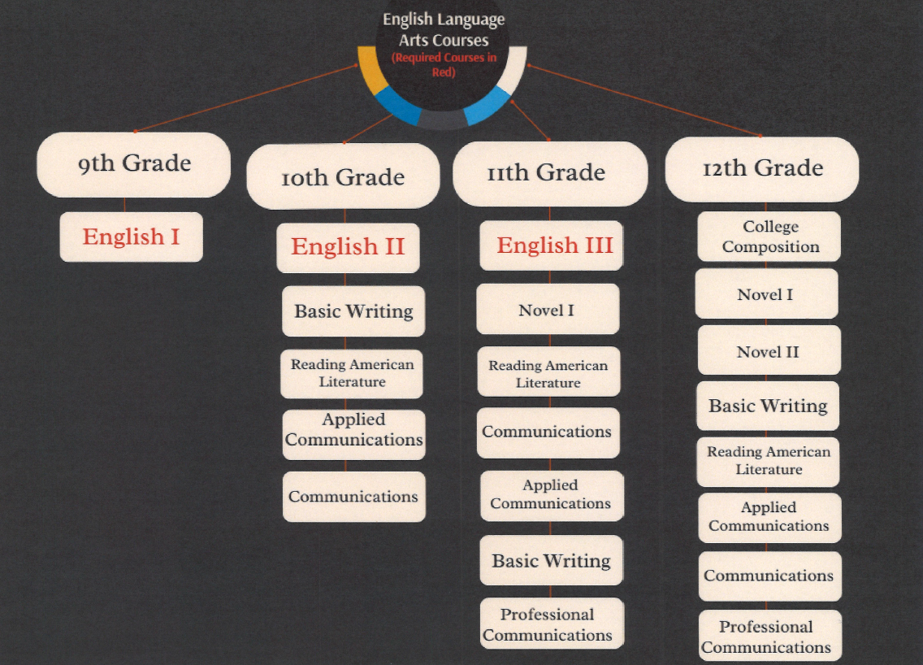

ENGLISH I (RAI Core Course) 2 Credits Full Year Course
Required for all 9th Grade

During the first semester, the freshmen will be using McDougal, Littel Literature, Orange Level, which includes a variety of fiction and nonfiction, poetry, and drama. They will read the Shakespearean drama Romeo and Juliet and the novel To Kill A Mockingbird second semester.

During the study of short stories, students will be introduced to numerous literacy terms, the understanding of which is necessary to adequately discuss the reading selections. The goal for this semester is to have students understand the make-up of a short story or novel, the elements that can be found within the work, and the ideas (themes) that can be extracted through interpretive thinking.

The material read during this quarter exposes the students to various cultures and ethnic groups. They have an opportunity to read about the plights of those people who struggle for recognition or independence. The stories also offer an insight into lifestyles outside the Midwest. Through careful reading the students can not only learn from the reading but also experience lifestyles of people in parts of our country and the world.

During the year, Grammar and Composition is required for all Freshmen. In this course the students are given a review of traditional grammar, including the parts of speech, parts of a sentence, phrases and clauses. The students then move on to
word usage and correct use of verbs and pronouns.

ENGLISH II (RAI Core Course) 2 Credits Full Year Course
Required for all 10th Grade

This course is designed to explore and reinforce the foundations of critical thinking in communication through listening, speaking, reading, and writing. Students will expose themselves to new ideas, generate ideas of their own, and develop ways to communicate those ideas to others. This course will combine the study and analysis of literature, the development of research writing, and the applications of mechanics and grammar. These skills will be taught and built upon consistently throughout the year through units of writing and literature. Some of the writing pieces students will work on are: reflective writing, compare/contrast writing, cause/effect writing, argumentative writing, and research writing. Some of the literature we will study will include: Pride and Prejudice, Lord of the Flies, Animal Farm, A Raisin in the Sun, and works by Edgar Allan Poe, F. Scott Fitzgerald, and Ernest Hemingway. We will also read some more modern writing including fiction and non-fiction pieces.

ENGLISH III (RAI Core Course) 1 Credit One Semester Course
Required for all 11th Grade (1st Semester)

The first quarter of English III deals with American Literature, primarily poetry and short story. The second quarter deals with grammar. During both semesters, students work with vocabulary to improve reading skills and test scores.

BASIC WRITING (RAI Core Course) 1 Credit One Semester Course
Elective for Grades 10, 11, and 12

Basic Writing will focus on an overall review of what great writing entails. We will start with reviewing the components of a well-written paragraph that includes an effective topic sentence, great supporting details, and a concluding sentence. We will move from effective paragraphs to effective essays as the semester progresses. A variety of essays will be written including: cause-effect, comparison, argumentative, problem-solving, reaction essays, and exam question essays. Embedded throughout this curriculum will be numerous activities to help students build better vocabulary for their writing.

THE NOVEL I (RAI Core Course) 1 Credit One Semester Course
Elective for Grades 11 and 12

The goal of the course is to explore classic and contemporary novels dealing with basic human experiences such as maturing, learning self-awareness, developing relationships with others, and examining a person’s place in society. Traditional classics, such as Of Mice and Men, One Flew Over the Cuckoo’s Nest and The Great Gatsby will be read.

COMMUNICATIONS (RAI Core Course) 1 Credit One Semester Course
Required in Grade 10, 11, or 12 OR Applied Communications

This course is designed to provide an opportunity for students to practice speaking publicly in multiple capacities. Students will develop skills related to planning, preparing, and presenting a variety of speeches. To begin the semester, students will learn about and practice using presenting skills, also considered the ‘non-content’ elements of speaking which include: poise, voice, life, eye contact, gestures, and speed. Students will then move on to the ‘content’ elements of speaking which include generating, forming, developing, practicing, and delivering various kinds of informal and formal speeches. Some of the speeches given will include: informative, persuasive, demonstrative, and impromptu to name a few.

APPLIED COMMUNICATIONS (RAI Core Course) 1 Credit One Semester Course
Required for Grades 10, 11, or 12 OR Communications

This course is designed to provide an opportunity for students to practice communicating in meaningful ways, from one-on-one communication activities to group speaking activities. To begin the semester, students will learn about and practice using presenting skills, also considered the ‘non-content’ elements of speaking which include: poise, voice, life, eye contact, gestures, and speed. Students will then present a variety of informal speeches and partake in group communication activities. Informative speeches and communication activities will cover topics such as: personal experience storytelling, most embarrassing moment speeches, introduction and acceptance speeches, partner speeches, and impromptu speeches to name a few.

NOVEL II (RAI Core Course) 1 Credit One Semester Course
Elective in Grade 11 or 12
Prerequisite: Novel I

This one-semester elective course for Seniors will be an independent reading course with grade determined by contract. Students will select works from a pre-determined reading list and after the reading of each novel will demonstrate understanding through written and/or oral reports.

READING AMERICAN LITERATURE (RAI Core Course) 1 Credit One Semester Course
Elective in Grades 10, 11 and 12 (2nd Semester)

This course studies American Literature from the 1900s to the present. Students will read White Fang, The Call of the Wild, A Separate Peace, and The Things They Carried. Other works from American authors will also be studied as time permits. Building comprehension and vocabulary skills will be emphasized.

COLLEGE COMPOSITION (RAI Core Course) 1 Credit One Semester Course
Elective for Grade 12

This class is designed to prepare students for the rigorous writing demands of college and the future workforce. This will be done through intensive grammar study, frequent writing practice, and weekly online discussions. Throughout the semester, students will complete various essays, short writing assignments, and one research essay in APA format. Before we start writing, students will examine the writing process, and the steps required to compose an effective essay. The writing process also involves personal, peer, and teacher editing before a final draft is submitted.

PROFESSIONAL COMMUNICATIONS (RAI Core Course) 1 Credit One Semester Course
Elective in Grade 11 or 12

This course is designed to help students develop fundamental communication skills for a career in the workplace. It will involve learning about and practicing skills in communicating in today’s digital, social, and mobile world, collaborating using interpersonal skills and business etiquette, and crafting messages for digital channels. Involved in the class will be a comprehensive coverage of writing, listening, and using basic business English along with the latest technology in order to craft effective communication in the workplace.

Back to the Table of Contents

MATHEMATICS

Three years of Math (6 semester credits) are required for graduation.
The freshmen class is ability-grouped in their mathematics classes of General Math, Pre-Algebra, or Algebra I.

Math Progressions:

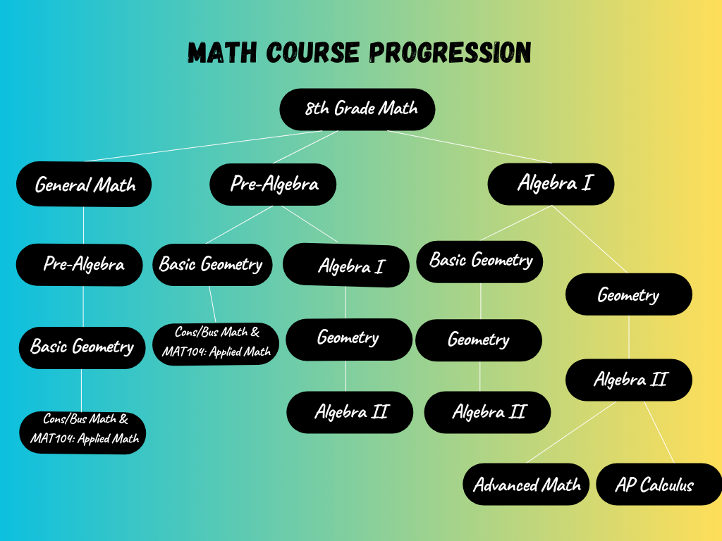

GENERAL MATH 2 Credits Full Year Course
Including May Term

General Math is available to freshmen with below average mathematical skills, through instruction of this course, the student will:
- improve their mathematical skills.
- understand the need of mathematics in the world of work
- obtain a feeling of success in performing mathematics.

Students will be expected to work realistic problems focusing on real application of mathematics.

PRE-ALGEBRA 2 Credits Full Year Course
Including May Term
Pre-requisite: 8th grade math or General Math – Grades 9 and 10

This class is designed for a transition into the Algebra I course. Students must have successfully completed eighth grade math or one year of general math. Students will cover topics such as: algebraic expressions, working with factors, fractions, and exponents, solving equations and inequalities, solving linear functions, finding area and volume, and also working with right triangles.

ALGEBRA I (RAI Core Course) 2 Credits Full Year Course
Including May Term
Pre-requisite: 8th Grade Math or Pre-Algebra

This is a course extending basic mathematical concepts to the use of variables. Solving problems with an unknown will also be presented. Students assigned to this class must have a sound math background and will improve their logical thinking. This course provides the fundamentals of a standard algebra course: simplifying variable expressions, solving equations, graphing linear and quadratic equations, and problem solving.

BASIC GEOMETRY 2 Credits Full Year Course
No May Term
Pre-requisite: Algebra I. - Elective in Grades 10, 11, or 12

GEOMETRY (RAI Core Course) 2 Credits Full Year Course
Including May Term
Pre-requisite: Algebra I. - Elective in Grades 10, 11 and 12

In this course, the student will:
- Work with points, lines and planes
- Use reasoning and proof
- Work with parallel and perpendicular lines
- Solve problems with congruent triangles
- Study relationships within triangles
- Solve problems involving quadrilaterals
- Find area, surface area & volume of geometric figures
- Solve problems using trigonometry

ALGEBRA II (RAI Core Course) 2 Credits Full Year Course
Including May Term
Pre-requisite: Algebra I and Geometry

Algebra II is the third class in our series. You must take Geometry as a prerequisite to Algebra II. Algebra II will cover the topics:
1) Tools of Algebra
2) Functions, Equations, & Graphs
3) Linear Systems
4) Matrices
5) Quadratic Equations and Functions
6) Polynomials
7) Radical Functions
8) Exponential and Logarithmic Functions
9) Rational Functions
10) Quadratic Relations
11) Sequences and Series
12) Probability and Statistics
13) Periodic Functions and Trigonometry
14) Trig Identities and Equations

Algebra II is the prerequisite to Calculus. Juniors must continue Algebra II through May Term. You will need to take this class during May Term if you plan on taking AP Calculus or Advanced Math the following year. Seniors may opt out of May Term Algebra II.

ADVANCED MATH (RAI Core Course) 2 Credits Full Year Course
No May Term
Pre-requisite: Algebra II – Grade 11 & 12

This class is for students who would like to take a fourth year of math but do not wish to take calculus. The topics in this class will cover pre-calculus topics; ACT prep; history of math; and real-world situations. The students will cover topics in Trigonometry, Discrete math, Analytic Geometry, and algebraic functions. The book uses numerous examples, real-world examples, graphs, diagrams and other illustrations that help students visualize concepts.

CONSUMER/BUSINESS MATH 1 Credit One Semester Course
No May Term
Pre-requisite: Pre-Algebra Grades 11 and 12

This class will cover topics in mathematics that relate to business and personal finance. It will cover topics such as checking accounts, insurance, taxes, the stock market, loans, and much more. We have not selected a textbook for this class yet so we can’t list all of the topics that will be covered.

MAT104-C APPLIED MATH TOPICS 1 HS credit/3 NCC Credits One Semester Course
Grades 9-12

This course is designed to give you a thorough review of the four basic functions of addition, subtraction, multiplication, and division of whole numbers, decimals, fractions, integers, measurements and percents. Basic linear equations and basic geometric figures for perimeter, area, and volume will be covered. You are then given exercises in using these mathematical skills in special occupational applications.

AP CALCULUS (AB) (RAI Core Course) 2 HS Credit/ 3 College Credits Full Year Course
Includes May Term
Pre-requisite is Algebra II and instructor’s approval. College credits are dependent on receiving a 3 or above on the end of year AP exam.

This class is a full year course and the content is comparable to a Calculus I course at colleges and universities. It is expected that the students that take this course will seek college credit from an institution of higher learning. To get college credit, students will need to take a comprehensive final exam that is administered within the first two weeks of May each year. The result of that test determines if they will receive college credit.

The student will also receive high school credit for taking this class. So, even if they do not do well enough on the test to receive college credit, they will still get their high school credit assuming they have passed the class.

This class will be extremely challenging and have a very demanding workload.
Daily attendance is very important.

Back to Table of Contents

SCIENCES

Three years of science (6 semester credits) are required for graduation. (Including General Science, Biology, and 2 Central Lyon elective credits)

Science Progression:

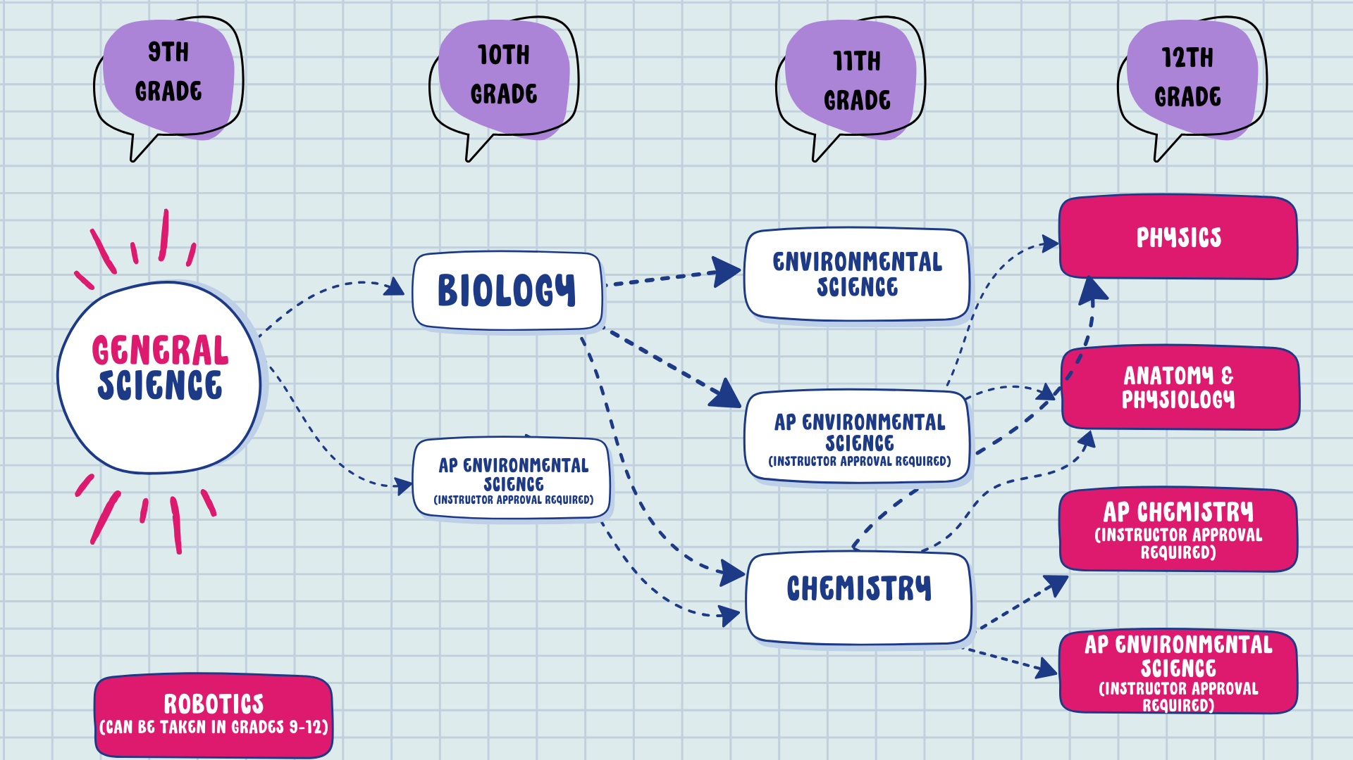

GENERAL SCIENCE (RAI Core Course) 2 Credits Full Year Course
Required for Grade 9 No May Term

Physical Science is a yearlong, full credit, required course, available to freshmen with no pre-requisites. Through instructions in this course the student will:
- practice laboratory skills and use safety procedures in the physical science laboratory.
- understand physical laws explaining the relationship between matter and energy.
- illustrate observation and experimentation are the basis of scientific inquiry and experimentation.
- realize many technological developments utilize the properties of light and sound.
- understand the effective use of energy now and in the future is linked directly to scientific knowledge and human resourcefulness.
- examine a variety of physical science careers.

Students will be expected to show competency in laboratory procedures and safety as well as account for the basic physical science concepts.

BIOLOGY (RAI Core Course) 2 Credits Full Year Course
Required for Grade 10 or Applied Biology No May Term

One of two options to fulfill the requirement of sophomore biology.
This course is designed as an inquiry-based curriculum. It not only provides students with an ability to understand fundamental principles but allows students to apply these principles to their everyday lives. Through instruction in this course, students will:
- learn about the various life processes and how they occur
- distinguish between living and nonliving things
- recognize the cell, its part, and their functions
- debate current issues involving various living things
- study the various pathogens and how they are transmitted
- understand the human immune system and how it works
- examine means for preventing and curing disease
- learn about various diseases and their genetic links
- students will examine the expression and inheritance of traits
- understand modern genetics
- know DNA as the blueprints of life and the changes that occur with it
- perform various dissections
- understand various systems of the human body
- learn the events involved in growth, development, and change
- discover external factors that affect organisms
- understand the life cycle

AP ENVIROMENTAL SCIENCE 2 Credits Full Year Course
Grades 11, 12, sophomores with instructor approval.
Pre-requisite: Students will have completed two years of high school laboratory science and one year of algebra.

The goal of the Honors Environmental Science course is to provide students with the scientific principles, concepts, and methodologies required to understand the interrelationships of the natural world, to identify and analyze environmental problems both natural and human-made, to evaluate the relative risks associated with these problems, and to examine alternative solutions for resolving or preventing them. Students will understand that: 1) Science is a process. 2) Energy conversions underlie all ecological processes. 3) The Earth itself is one interconnected system. 4) Humans alter natural systems. 5) Environmental problems have a cultural and social context. And 6) Human survival depends on developing practices that will achieve sustainable systems.

ENVIRONMENTAL SCIENCE – (RAI Core Course) 2 Credits Full Year Course
Grades 11, 12 No May Term

The goal of the Environmental Science course is to provide students with the scientific principles, concepts, and methodologies required to understand the interrelationships of the natural world, to identify and analyze environmental problems both natural and human-made, to evaluate the relative risks associated with these problems, and to examine alternative solutions for resolving or preventing them.

CHEMISTRY (RAI Core Course) 2 Credits Full Year Course
Pre-requisite: Algebra I No May Term
Elective in Grades 11 and 12

Through instruction in this course, the student will:
- understand the properties of matter.
- develop proportional reasoning skills.
- perform laboratory experiments to reinforce concepts and to understand the importance of uncertainty in scientific work.
Students will be expected to demonstrate their understanding of matter, they will also be expected to do careful laboratory work and write a report on the results.
Topics covered in this one-year course include: identifying chemical and physical changes; naming and writing formulas for substances; the mole concept and molar mass; chemical equations and balancing; applying the mole concept to balanced chemical equations; Gases - Boyle’s Law, Charles’ Law Ideal Gas Law; models of the atom; chemical bonding; solutions - molarity.

AP CHEMISTRY (Independent Study) 2 credits Full Year Course
Grade 12 (Pre-requisite: Chemistry) *Instructor Approval

Following the curricula recommended by the College Board, AP Chemistry courses usually follow high school chemistry and second-year algebra. Concepts covered may include the structure of matter; bonding of intermolecular forces; chemical reactions; kinetics; thermodynamics; and chemical equilibrium. For each concept, these courses emphasize the development of scientific inquiry and reasoning skills, such as designing a plan for collecting data, analyzing data, applying mathematical routines, and connecting concepts in and across domains. AP Chemistry courses include college-level laboratory investigations.

PRINCIPLES OF TECHNOLOGY/ROBOTICS (RAI Core Course) 2 Credits Full Year Course
Grades 9-12 Option to continue during May Term

Principles Of Technology is a high school-level survey course of engineering. The course exposes students to some of the major concepts that they will encounter in a post-secondary engineering course of study. Students have an opportunity to investigate engineering and high-tech careers. POE gives students the opportunity to develop skills and understanding of course concepts through activity-, project-, and problem-based (APPB) learning. Used in combination with a robotics curriculum approach, APPB learning challenges students to continually hone their interpersonal skills, creative abilities, and problem solving skills based upon engineering concepts. It also allows students to develop strategies to enable and direct their own learning, which is the ultimate goal of education.

PHYSICS (RAI Core Course) 2 Credits Full Year Course
Pre-requisites: Algebra I, Geometry, Algebra II Option to continue during May Term
Elective in Grade 12

Minds On Physics (MOP) is an activity-based, full year course. The activities are designed to help students learn to use physics concepts to analyze and solve problems, and to curb students’ natural tendency to learn by rote and to engage in formula manipulation. Working in groups, students use concepts to analyze problem situations and answer open-ended questions, explore the meaning of concepts through inquiry and hands-on activities, and share personal reflections on prior experiences.
The course covers two full books- the first book covers Motion (velocity, speed, acceleration, position, distance, displacement), and the second book covers Interactions (vectors, forces, Newton’s laws of motion, free-body diagrams). Part of a third book is covered titled Conservation Laws and Concept-Based Problem Solving.

ANATOMY & PHYSIOLOGY (RAI Core Course) 2 Credits Full Year Course
Elective in Grade 12 No May Term

This advanced science course is designed for students to investigate the structure and function of the human body and its components, as well as to realize its amazing design. This course will be a comprehensive and in-depth study of the systems of the body such as the skeletal, muscular, nervous, cardiovascular, endocrine, respiratory, digestive, urinary and reproductive systems. Anatomy and Physiology is taught as a combination of lecture/discussion with some laboratory work as well. The course is primarily open to seniors and is recommended for those interested in pursuing studies in the nursing, medical and science therapy fields.

Back to Table of Contents

SOCIAL STUDIES

Three years of social studies (6 semester credits) are required to graduate. (Including American History, World History, American Government and 1 Central Lyon elective credit.)

*** Students who complete a regular session in the Legislative Page Program of the general assemble at the state capitol will be credited ½ credit of Social Studies.

Social Studies Progression:

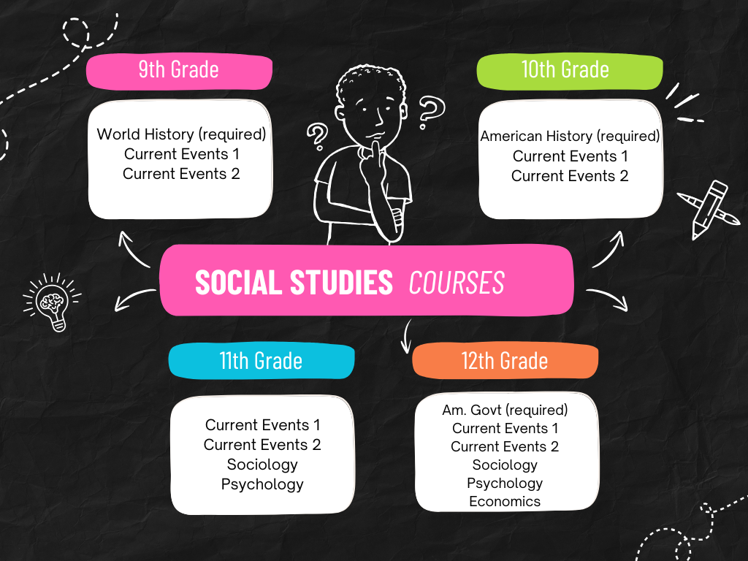

AMERICAN HISTORY (RAI Core Course) 2 Credits Full Year Course
Required for Sophomores Includes May Term

This course covers American history from Reconstruction to the present. Students will develop an understanding of today’s United States and world by examining major social, political, economic, military, and geographic events and trends throughout the past.

AMERICAN GOVERNMENT (RAI Core Course) 1 Credit One Semester Course
Required for Seniors No May Term

Students will gain a basic understanding of world governments and a deeper knowledge of the U.S. governmental system. The course includes a study of the U.S. Constitution, how its principles have shaped our government, and how political parties and the election process function. Students will also learn about the rights and responsibilities of citizens.

ECONOMICS (RAI Core Course) 1 Credit One Semester Course
Financial Literacy elective in Grade 11 & 12 No May Term

Students will learn key economic principles and explore how the U.S. economic system works. Topics include personal finance, financial markets, fiscal policy, the Federal Reserve System, monetary policy, and international trade.

SOCIOLOGY (RAI Core Course) 1 Credit One Semester Course
Elective for Juniors or Seniors No May Term

This course examines how groups influence human behavior. Students will study social institutions, socialization, social problems, and social movements. Additional topics include adolescence, deviance, race, education, and religion. This college-prep course is recommended for students planning to attend a four-year college.

PSYCHOLOGY (RAI Core Course) 1 Credit One Semester Course
Elective for Juniors and Seniors No May Term

Students will explore how people think, behave, and interact with one another. Topics include learning, states of consciousness, mental illness, therapeutic approaches, and stress. This college-prep course is highly recommended for students planning to attend a four-year college.

WORLD HISTORY (RAI Core Course) 2 Credits Full Year Course
Required for Freshman No May Term

World history tells the stories of people, events, and institutions from the earliest civilizations to modern times. Focus will be placed on the beliefs of those in the past, the ways they met their economic needs, the social and political institutions they formed, and the culture they transmitted from one generation to another.

This course also integrates the teaching of Geography and History. Geography is not taught as a separate subject but is included in every lesson as needed, through maps, diagrams, photographs, and text descriptions.

CURRENT EVENTS I & II 1 Credit One Semester Course
Elective in Grades 9 - 12 No May Term

This course helps students better understand the rapidly changing world around them by examining major local, state, national, and global events as they unfold. Students will learn how to analyze news sources, evaluate credibility, identify bias, and compare reporting across different media platforms. Students will develop informed opinions, strengthen their critical-thinking skills, and practice respectful dialogue. By the end of the course, students will be better equipped to participate as thoughtful, engaged citizens in an information-rich society.

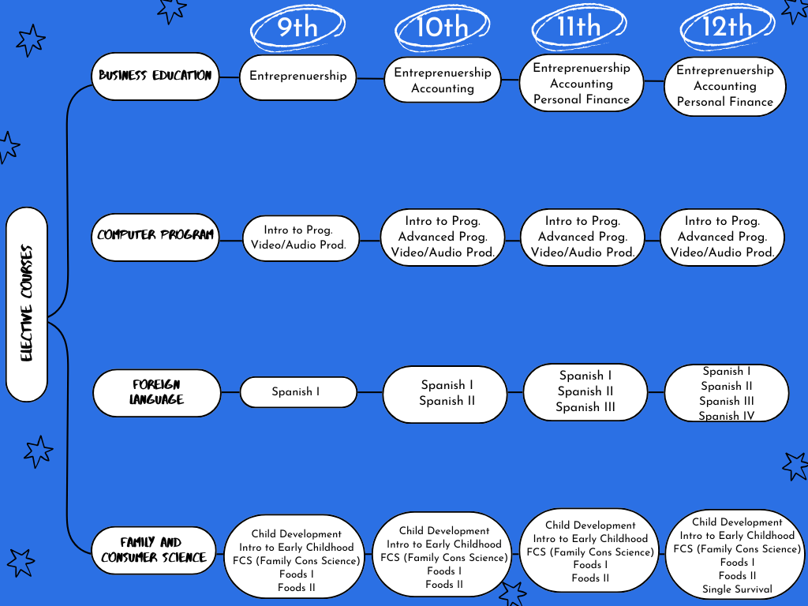

BUSINESS EDUCATION PROGRAM

With input from a vocational advisory committee and in partnership with Northwest Community College of Sheldon, IA, we offer students a technical education program containing three-sequential units in the area of General Business.

INTRODUCTION TO BUSINESS 1 Credit One Semester Course
Elective for Grades 9 and 10 only.
This course is a prerequisite for Senior Work Ready Program

Introduction to Business provides students with a broad, practical foundation in how the business world works and the skills needed to participate in it. Students explore the major functions of business-including management, marketing, finance, entrepreneurship, and operations-while learning how organizations make decisions and create value in a global economy.

ACCOUNTING 2 Credits Full Year Course
Elective for Grades 10,11 & 12

Accounting I will teach students of the basic concepts that happen in day-to-day operations of proprietorships, corporations, and partnerships. Financial record keeping is an essential element for business to function efficiently. Even though accounting is often referred to as the language of business, almost all people use knowledge of accounting in personal financial activities. Understanding the accounting cycle is the basis of a first-year accounting course. The students will be introduced to fundamental transactions for service and merchandising businesses organized as sole proprietorships, partnerships, and corporations. Students will also have a better understanding of payroll procedures and banking activities. The program will provide ample opportunities to practice basic accounting skills through business simulations. Although high school accounting students will be able to find good entry-level accounting or bookkeeping positions, the real demand is in the professional accounting area. For those students who desire to become a professional accountant, they should continue with Accounting II and plan to continue their education through post-secondary options. Students will also have the opportunity to use computer applications through automated accounting software.

ENTREPRENEURSHIP 1 Credit One Semester Course
Elective for Grades 9, 10,11 & 12 (2nd Semester)

Entrepreneurship is a one semester course. The focus of the course will be the exploration of owning your own business. The entrepreneurial world is changing and so are we. Students today need to realize becoming a business owner is a career option. Entrepreneurship will encourage students to examine all the major steps involved in starting a business: Ownership, Strategy, Finance, and Marketing.

PERSONAL FINANCE 1 Credit One Semester Course
Financial Literacy Elective in Grades 11 & 12

Personal Finance is a one semester course. The course is most applicable to junior or senior students. The purpose of the course is to contribute to improved economic understanding through a study of the business and economic environment in which we live. Economic understanding is geared toward the development of individuals who 1) are knowledgeable of our American business system, 2) are competent in managing their own business affairs, and 3) prepared to present themselves professionally when searching for employment.

COMPUTER/OFFICE PROGRAM

INTRODUCTION TO COMPUTER PROGRAMMING 2 Credit Full Year Course
Elective for grades 9 – 12

The Intro to Computer Programming courses provide students with the knowledge and skills necessary to construct computer programs in JavaScript. Students learn the basics in how to structure, create, document, and debug computer programs. Advanced courses may include instruction in object-oriented programming to help students develop applications for Windows, databases, multimedia, games, mobile and/or Web environments. An emphasis is placed on design, style, clarity, and efficiency. In these courses, students apply the skills they learn to relevant authentic applications. Other than coding, topics covered in this class are the structure of the internet, basics of algorithms, and basic cybersecurity and the global impacts of it.

ADVANCED PROGRAMMING 2 Credit Full Year Course
Elective for grades 10-12

Advanced Programming builds off the Intro to Programming course. The course introduces students to software engineering and object-oriented programming and design using Java programming language. This curriculum covers a broad range of topics, including the design of solutions to problems, the use of data structures to organize large sets of data, the development and implementation of algorithms to process data and discover new information, the analysis of potential solutions, and the ethical and social implications of computing systems.

VIDEO AND AUDIO PRODUCTION /YEARBOOK (Independent Study) 2 Credit Full Year Course
Elective for grades 9-12

Video & Audio Production will provide students with the knowledge and skills necessary for television, video, web streaming, and podcasting production. You will learn about writing scripts, camera operation, use of graphics and other visuals, lighting, audio techniques, editing and production principles in this course. During this course you will create graphics and videos used for the video board, produce your own videos using adobe premiere pro, help with the school’s web streaming and social media creation, create scripts for announcers, learn about on-screen graphics & produce podcasts.

VIDEO/AUDIO/COMPUTER APPLICATIONS 1 Credit One Semester Course
Elective in Grades 9-12 No May Term

This course will provide students with the knowledge and skills necessary to use different types of applications that maybe be required for television, video and podcasting production. You will learn about writing scripts, camera operation, use of graphics and other visuals, audio techniques, editing and Production principles in this course. During this course you will be creating different types of projects using, but not limited to, the following programs: Microsoft Office Apps, WeVideo, Canva and Adobe.

FOREIGN LANGUAGE

SPANISH I (RAI Core Course) 2 Credits Full Year Course
Elective in Grades 9-12 Includes May Term

Spanish I is an introductory course to learn basic communication in the Spanish language and to understand and appreciate Hispanic cultures through the modes of listening, speaking, reading, and writing using a variety of topics.
There is a strong emphasis on class participation with an average of 20 minutes outside daily preparation.

SPANISH II (RAI Core Course) 2 Credits Full Year Course
Pre-requisite: Spanish I Includes May Term
Elective for Grades 10-12

Spanish II is a continuation of Spanish I and is designed to improve communication in the Spanish language and understanding and appreciation of Hispanic cultures through the modes of listening, speaking, reading, and writing.
There is a strong emphasis in class participation with an average of 25 minutes outside daily preparation.

SPANISH III (RAI Core Course) 2 Credits Full Year Course
Pre-requisite - Spanish II Optional May Term
Elective for Grades 11-12

Spanish III / College credit course is a continuation of Spanish II and is designed to improve communication in the Spanish language and understanding and appreciation of Hispanic cultures through the modes of listening, speaking, reading, and writing.
Students will apply their knowledge in compositions and projects, and through testing and speaking proficiency. Except for explaining new grammatical concepts, students will be expected to always speak in the target language.
There is a strong emphasis on class participation with an average of 25 minutes outside daily preparation.

SPANISH IV (RAI Core Course) 2 Credits Full Year Course
Pre-requisite: Spanish III No May Term
Elective in Grade 12

The objective of this class is to increase proficiency in Spanish language skills (listening, reading, speaking, writing, and culture/history) essential to communicative language learning. This is a Spanish intensive intermediate course where the expansion of intercultural awareness will play a key role among the topics and activities covered by each lesson. Students will improve upon elaboration of class topics in Spanish through discussions, essays, projects and presentations.
There is a strong emphasis on class participation with an average of 30 minutes outside daily preparation.

FAMILY AND CONSUMER SCIENCES

With input from a vocational advisory committee and in partnership with Northwest Community College of Sheldon, IA, we offer students a technical education program containing three sequential units in the area of Family and Consumer Sciences.

CHILD DEVELOPMENT 1 Credit One Semester Course
Elective for Grades 9, 10, 11, and 12

Have you thought about what it takes to work with children? Ever wondered why you are the way you are? You will
find some of the answers in this Child Development course. The class includes units in pregnancy and delivery, birth defects, the areas of development, leadership and guidance techniques. Explore topics on parenting and child related careers. Students are actively involved in individual and group projects and occasionally work with small children.

EARLY CHILDHOOD EDUCATION 1 Credit One Semester Course
Elective for Grades 10, 11 & 12 (*seniors will not be able to get CDA certification)

This course prepares students for careers in early childhood education and earning their CDA credential. Students complete 120 classroom hours and gain hands-on experience working at Kids Club Daycare. A total of 480 work hours is required before taking the CDA exit exam.

FOODS I 1 Credit One Semester Course
Elective for Grades 9, 10, 11, and 12

This course is an introductory course which includes “hands-on” practice in food preparation techniques, kitchen safety, equipment use, nutrition, menu planning, leadership development, and careers in food related industries. This course provides the foundation for Foods II.

FOODS II 1 Credit One Semester Course
Pre-requisite: Foods I
Elective for Grades 9, 10, 11, and 12

The course explores many aspects of foods ranging from personal food choices to a worldwide look at the future of food. It will broaden a person’s knowledge and understanding of nutrition, along with basic meal planning and food preparation skills. Meal planning will be done with the awareness of nutrition, eye appeal, economy and convenience.

SINGLE SURVIVAL 1 Credit One Semester Course
Elective for Grade 12

In this course, students will gain the skills and knowledge needed to confidently approach the challenges and decisions faced as independent adults. Topics in this course will include communication, goal setting, decision making, personal income, risk management, career research, develop a resume, and gain “hands on” experience in the kitchen.

FCS (Family Consumer Science) 2 Credit Year Long Course
Elective for Grades 9-12 (Can be an independent study)

Developing essential life skills means honing your character, sparking your creativity and critical thinking, refining your communication, acquiring practical knowledge, and preparing for your future career. FCS is all about equipping you with the tools to thrive, strengthen your family, pursue your career goals, and make a positive impact in your community. Let's conquer these life skills and own our journey to success!

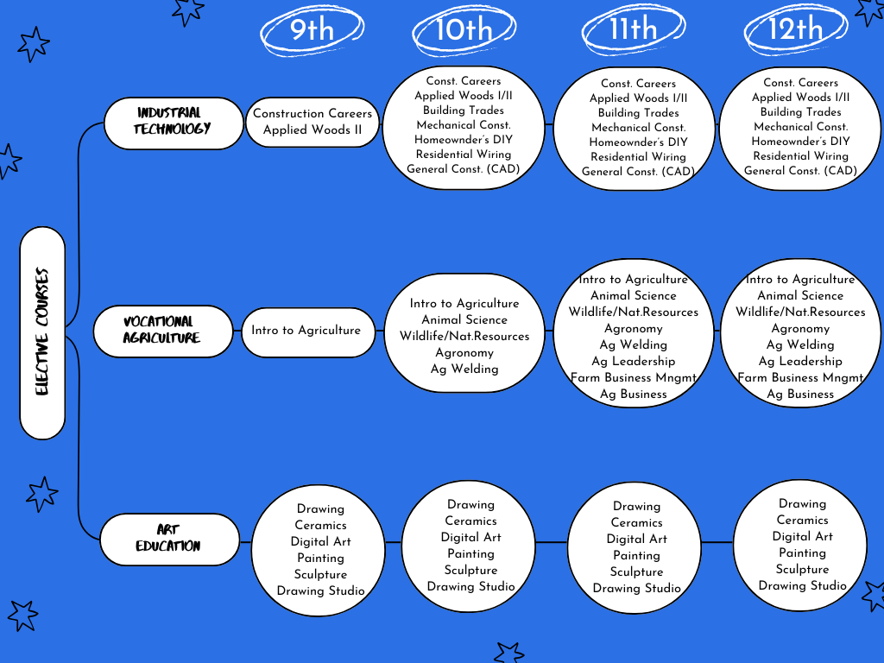

INDUSTRIAL TECHNOLOGY

With input from a vocational advisory committee and in partnership with Northwest Community College of Sheldon, IA, we offer students a technical education program containing three-sequential units in Construction Trades.

- Cost of Supplies for projects will be at student’s own expense.
- All students will supply their own safety glasses or purchase them from the school.
- All students will supply their own tape measure.

*CONSTRUCTION CAREERS 1 Credit One Semester Course
Elective in Grades 9, 10, 11, and 12

This is a comprehensive course offered to all students who have had no technology courses. The course will emphasize an introduction to woodworking, hand tool usage, portable power tool usage, stationary power tool usage, computer aided design, electricity, metal fabrication, and finally some building construction. It is also an introduction to general shop safety and cleanup, proper tool usage, assembly operations, design consideration, and ordering specifications. Experience is provided to aid students in developing a variety of different skills but also to give the student exposure to many different skilled trades to possibly pursue it further in the more advanced classes.

*Features: required projects and elective projects.

BUILDING TRADES AND MANUFACTURING I 2 Credits Full Year Course
Pre-requisite: Construction Careers
Elective in Grades 11, and 12

Building Trades is a two-hour elective block course, available to juniors, and seniors. Through instruction the student will:

- Understand all facets of basic carpenter construction.
- Understand how to read floor plans and blueprints for building construction.
- Understand how to formulate home construction estimates including a bill of materials, and cost estimates.
- Be exposed to available careers in the field of carpentry, such as electrical, plumbing and cabinetry.
- Practice shop skills (including proper use of tools) and use shop safety at all times.
- Understand the basic concepts of floor framing, wall framing, and roof framing.
- Be able to distinguish the difference between rough carpentry and finish carpentry
- Establish hands-on experience in residential electrical and plumbing

*Features: We will be constructing/assembling a home that will go through all the processes of building construction. This includes floor framing, wall framing, roof framing, interior flooring, cabinetry, installing windows and doors, plumbing, electrical, and other specific types of interior designs.

BUILDING TRADES AND MANUFACTURING II 2 Credits Full Year Course
Pre-requisite: Building Trades I
Elective in Grades 11, and 12

Building Trades II is a two-hour elective block course, available for juniors and seniors. This is for a second-year student that will be performing advanced versions of the tasks below. Through instruction in this course, the student will:

- Understand all facets of basic carpenter construction.
- Understand how to read floor plans and blueprints for building construction.
- Understand how to formulate home construction estimates including a bill of materials and cost estimates.
- Be exposed to available careers in the field of carpentry, such as electrical, plumbing and cabinetry.
- Practice shop skills (including proper use of tools) and always use shop safety.
- Understand the basic concepts of floor framing, wall framing, and roof framing.
- Be able to distinguish the difference between rough carpentry and finish carpentry
- Establish hands-on experience in residential electrical and plumbing

*Features: We will be construction/assembling a small-scale home that will go through all the processes of building construction. This includes floor framing, wall framing, roof framing, interior flooring, cabinetry, installing windows and doors, plumbing, electrical, and other specific types of interior designs.

APPLIED WOOD TECHNOLOGY (1st semester) 1 Credit One Semester Course Pre-requisite: Construction Careers
Elective in Grades 10, 11, or 12

The course is designed for the students who work to further regard wood applications. Students will develop and research technical skills. Special emphasis will be put on wood project assembly, the student will further his/her knowledge building a wood project, assembly with different portable tools, calculating the bill of materials, and be able to draw their own project.

*Features: Required project, then proceed to own project
* Student needs to be prepared to have a project in mind.

APPLIED WOOD TECHNOLOGY II (2nd semester) 1 Credit One Semester Course
Pre-requisite: Applied Wood Technology
Elective in Grades 9, 10, 11, or 12

The course is designed for the students who work to further regard wood applications. Students will develop and research technical skills. Special emphasis will be put on cabinet making and introduction on power tools, special setups, and tool safety.

*Strictly work on their own project
*Student needs to be prepared to have a project in mind.

MECHANICAL CONSTRUCTION 1 Credit One Semester Course
Elective in Grades 10, 11, 12

This course is a comprehensive course that includes theory with a laboratory setting for students to demonstrate what they have learned in the classroom. This course will show how Two-Cycle, and Four-Cycle gas engines are constructed, how they operate, what goes wrong, and how to service and repair them.

Through instructions in this course and in the laboratory setting the student will understand:

- Tools and Measuring Instruments
- Engine Construction and Principles of Operation
- Two-Cycle vs. Four-Cycle Engines
- Carburetion, Fuel and Emissions Control Systems, Ignition Systems
- Fasteners, Sealants and Gaskets, Lubrication Systems, Pistons
- Engine Inspection, Disassembly, and Cylinder Reconditioning
- Fuel System Service, Ignition System Service, Cooling Systems
- Bearing, Crankshaft, Valve, and Camshaft Service
- Lawn Care Maintenance

METAL CONSTRUCTION 1 credit One Semester Course
Elective in Grades 11 and 12

Metal Fabrication is a semester long, co-educational, elective course available to juniors and seniors. Through instruction in this course, the student will:
- Understand the many types and gauges of metal and many of their uses.
- Understand the following forms of welding: Arc, Wire Feed, Oxy-Acetylene, Brazing, and other state of the art welding methods
- Understand the different methods of metal bending and cutting including torch cutting and plasma cutting
- Understand and practice proper technique for the above mentioned types of welding.
- Be exposed to available careers in the area of metal fabrication
- Understand and practice project planning including: project design and construction, bill of materials, and cost estimate.

ADVANCED METAL CONSTRUCTION 1 Credit One Semester Course
Pre-requisite: Metal Construction
Elective in Grades 11 and 12

Advanced Metal Fabrication is a continued semester long course that takes the principles learned in the basic metal fabrication class and continues into more advance levels of welding and fabrication.

*Features: Working and producing fire pits using the plasma cutter.

HOMEOWNER’S DIY 1 Credit One Semester Course
Elective in Grades 10, 11 and 12

This is a comprehensive course offered to all students who have had no industrial technology courses. It allows them to experience important hands-on skills with the idea that they will be a future homeowner. There is no need for any experience with tools or skills that they think will pertain to this course. It will give students the opportunity to learn a very diverse skill set that they will use for the rest of their life.

Upon completion of the HOMEOWNER’S DIY course, students will understand:

- Understanding how basic wood framing works
- Understanding how to install dry wall
- Understanding how to wire basic receptacles and switches
- The use of basic hand tools for certain installations
- Understanding how to use dry wall anchors to hang items on the wall
- Understanding how to install an interior door
- Understanding how to put in a doorknob
- Understanding how to install tile
- Understanding how to install vinyl plank flooring
- Learning the processes of vanity installation
- Understanding the plumbing process and hookup
- Understanding the installation of a faucet
- Learning the processes of painting
- Understanding the installation of wood trim
- Learning the process of installing carpet

The skills acquired in this course will be something that the students will use and have the capability to expand the rest of their lives. Students will not only learn the theory of each one of these skills but more importantly each student will have the physical opportunity to demonstrate each of these skills.

RESIDENTIAL ELECTRICITY CONSTRUCTION 1 Credit One Semester Course
Elective in Grades 10, 11, 12

This course will provide students with the basic knowledge and skills to begin employment as an electrician apprentice or electrician helper. The students will be instructed in tools and workplace safety and will learn about the generation and distribution of electrical power. Students will learn the concepts of electricity by designing and performing hands on work wiring various circuits used in residential, commercial and industrial applications. The students will learn overhead and underground service installation dealing with single phase and three phase systems, branch circuits and motor controls. Students will also become familiar with the national electrical code and how it pertains to the type of work they are performing. Methods of instruction will include lectures, demonstrations, discussion, films, and hands-on practice.

*Features: Assistance from Meyer Electric which leads to the students wiring the small house that the building trades and manufacturing class will construct.

GENERAL CONSTRUCTION (CAD) 1 Credit One Semester Course
Elective in Grades 10, 11, and 12
Introduction to Computer Aided Drafting is a course designed to give students hands on experience with tools and machines of drafting technology. Using traditional and computer drafting equipment the students will learn a written language where ideas are expressed in graphics. Students will be exposed to drafting programs such as Auto CAD, Auto CAD Fusion, Inventor and Revit. This course will be a very hands-on course for students as they will do a multitude of 2D and 3D drawings in each of these programs.
Upon completion of the CAD course, students will understand:
• Mechanical and architectural scales
• Line symbols and terms
• Computer hardware and software used in CAD
• CAD single and three view, isometric, oblique, and sectional drawings
• Floor, elevation, basement, sectional, and detail plan.

Back to the Table of Contents

VOCATIONAL AGRICULTURE

With input from a vocational advisory committee and in partnership with Northwest Community College of Sheldon, IA, we offer students a technical education program containing three-sequential units in the area of Agriculture.

AGRICULTURAL WELDING I 1 Credit One Semester Course
Pre-requisite: Intro to Ag.
Elective in Grades 10, 11, & 12; (8 students max.)

This course introduces students to the fundamental skills and safety practices required for agricultural welding. Emphasis is placed on learning proper shop safety, equipment setup, and operation of both SMAW (stick) and GMAW (MIG) welding processes. Students will develop foundational skills through hands-on practice with bead placement, joint preparation, and basic weld positions. By the end of the course, students will demonstrate competence in producing clean, structurally sound welds suitable for agricultural repair and fabrication work.

AGRICULTURAL WELDING II 1 Credit One Semester Course
Pre-requisite: Agricultural Welding I
Elective in Grades 10, 11, & 12; (8 students max.)

This course is a project-driven class where students apply their welding skills to design, build, and complete a variety of hands-on fabrication projects. The primary focus is on being able to plan a project and follow that plan. Students will plan project layouts, measure and cut materials, select appropriate welding techniques, and assemble components. Throughout the semester, students take responsibility for managing their own projects, working independently or in teams, to produce high-quality, fully completed final products. This course emphasizes craftsmanship, problem-solving, and seeing a project through from concept to completion.

INTRO TO AGRICULTURE 2 Credits Full Year Course
Grades 9-12
This foundational course provides students with a broad understanding of the agriculture industry, including its history, economic importance, and career opportunities. Students will explore various agricultural sectors, including animal science, agronomy, agribusiness, and agricultural mechanics. Hands-on activities, SAE projects, FFA involvement, and lab experiences will enhance student learning. Key topics include food production, natural resource conservation, agricultural marketing, and the role of technology in modern farming. This course prepares students for advanced agricultural studies and potential careers in the field.
ANIMAL SCIENCE 2 Credits Full Year Course
Grades 10-12
Prerequisite: Intro to Ag

This course provides students with a foundational understanding of the animal industry, including animal anatomy, physiology, nutrition, genetics, reproduction, health, and management. Students will explore livestock production systems, breed classifications, and industry practices for beef cattle, swine, sheep, goats, dairy cattle, poultry, equine, and companion animals. Through hands-on learning and scientific analysis, students will develop the skills necessary to evaluate animal health, nutrition, and production methods. This course is ideal for students interested in careers in veterinary science, livestock production, or animal management.

AG ISSUES/LEADERSHIP 1 Credit One Semester Course
Grades 11-12

This course prepares students to become leaders and effective communicators in the agriculture industry. Through research, discussion, and reflection, students will explore current agricultural issues and ethical decision-making in agribusiness. Emphasis is placed on professional communication, critical thinking, and understanding of the role of culture in agriculture. This class is ideal for students interested in leadership, advocacy, and careers in the agriculture industry.

AGRONOMY 1 Credit One Semester Course
Grades 10-12

This course provides students with a comprehensive understanding of soil science, crop production, and plant management in modern agriculture. Students will explore topics such as soil conservation, fertilizers, plant classification, pest management, and precision agriculture. Through hands-on activities, scientific analysis, and discussions on Midwest crop systems, students will develop the knowledge needed to evaluate plant health, manage soil fertility, and understand the environmental impact of agricultural practices. This course is ideal for students interested in agronomy, environmental science, or careers in crop and soil management

FARM BUSINESS MANAGEMENT 1 Credit One Semester Course
Grades 11-12

This course provides students with an in-depth understanding of the business aspects of modern agriculture. Students will explore economic principles, financial management, marketing, business ethics, and government regulations as they relate to agribusiness. Through practical applications, students will learn budgeting, investing, advertising, and sales techniques essential for managing a successful farm operation. This course will do much in dealing with the FFA farm, including maintenance, marketing animals, and general upkeep of the farm. This course is ideal for students interested in farm management, agribusiness, agricultural economics, or entrepreneurship in the agriculture industry.

WILDLIFE & NATURAL RESOURCES 1 Credit One Semester Course
Grades 10-12

This course provides students with hands-on experience in natural resources and ecology. Students will explore land use, water quality, soil science, wildlife conservation, and environmental stewardship. Key topics include ecosystem dynamics, soil and water conservation, the impact of agriculture on natural resources, and the role of environmental agencies. Hands-on projects, such as soil and water testing, wildlife habitat management, and taxidermy, will enhance student learning. This course prepares students for careers in environmental science, conservation, and agriculture.

AGRI-BUSINESS 1 Credit One Semester Course
Grade 11 & 12
Prerequisite: Intro to Ag

This course provides students with a foundation in agricultural economics, financial management, and business operations. Students will explore record keeping, financial analysis, marketing, agricultural credit, and risk management while gaining hands-on experience in business planning. Through real-world applications, including budgeting, tax preparation, and market simulations, students will develop the skills necessary to manage or start an agricultural business. This course is ideal for students interested in farm management, agribusiness careers, or entrepreneurship in the agriculture industry.

Back to Table of Contents

ART EDUCATION

DRAWING I/DRAWING II 1 Credit One Semester Course

Elective: Grades 9 - 12

Introduction and exploration of various techniques in drawing. Students will learn to add shape and depth to their artwork and will use different applications including pencil, colored pencil and pastels.

DRAWING STUDIO-NCC 1 Credit/3 NCC Credit Hours One Semester Course
Elective for Grades 9, 10, 11 & 12

Drawing is a foundation course dealing with the practices and applications of basic drawing principles and techniques. Study research of the various mediums and compositional aspects is included.

CERAMICS I/CERAMICS II 1 Credit One Semester Course

Elective: Grades 9-12

Introduction and exploration of various techniques involving clay. Course will cover hand building and wheel building techniques as well as the application of finishing glazes. Sculptural techniques will be applied in many ways for several different finished products.

PAINTING I/PAINTING II 1 Credit One Semester Course
Elective: Grades 9-12

Introduction and exploration of various painting techniques. Students will study and use acrylics, tempera, watercolor and oil-based paints and work with a number of ways of applying paint to several surfaces. Students will spend some time viewing, discussing and evaluating the work of famous artists as well as their own works.

ART IS 1 Credit One Semester Course
Prerequisite: Any Art Course
Elective: Grades 11-12
Independent Study
Continuation of the Art courses as approved by the teacher.

SCULPTURE I/SCULPTURE II 1 Credit One Semester Course

Elective: Grades 9-12

This course will focus on different mediums available for 3-dimensional art. Plaster, wood, glass and other mediums will be used. Students will view famous works and artists as well as create their own designs.

DIGITAL ART 1 Credit One Semester Course
Elective: Grades 9-12

An Art Design class focused on using digital as the medium. Majority of the course will be developing skills using Photoshop. A few animation techniques will be covered as well as some graphic design concepts (using art to communicate ideas).

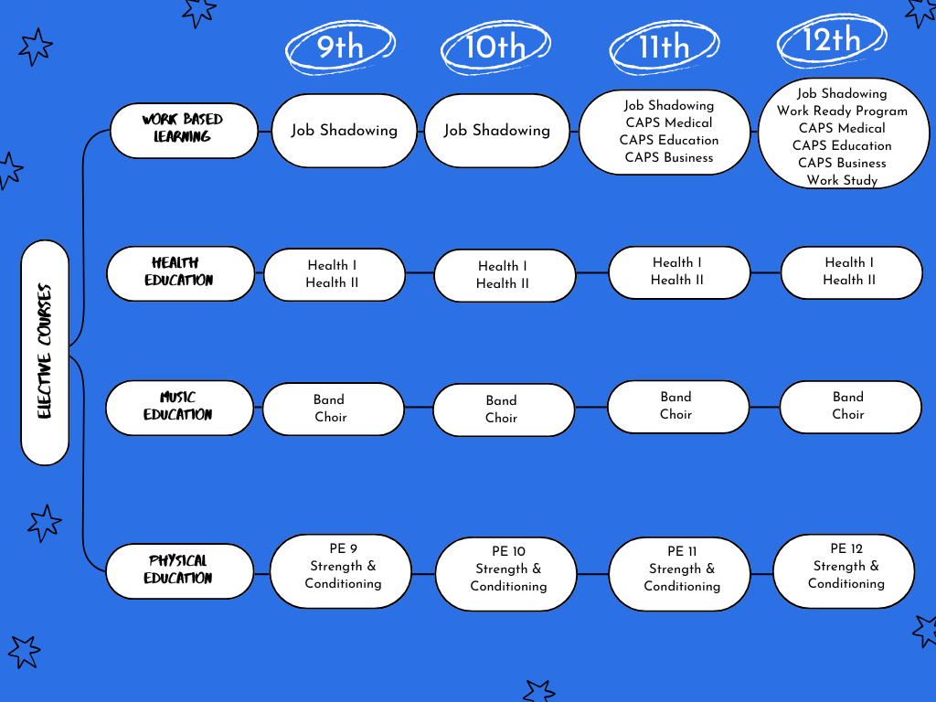

WORK-BASED LEARNING

CAPS Medical (Center for Advanced Professional Studies) 2 Credits One Semester Course
WBL 130 Career Exploration-NCC & WBL 154 Job Shadowing-NCC (1st or 2nd Semester)
Elective for Grades 11 or 12 (Cap of 6 students each semester)

Description:
CAPS Medical (Center for Advanced Professional Studies) is an opportunity for students to gain work placement experience at Avera Merrill Pioneer Hospital. This partnership exposes students to six areas of healthcare: radiology, laboratory, pharmacy, surgery, therapy, and clinic. CAPS Med is available to any Central Lyon High School student that is 16 years of age or older and meets the following requirements:
- Application Form
- 2 References (1 must be from a teacher)
- Student Interview (conducted by CAPS instructor, HS Counselor, and Avera leadership employees)
Interested students must register the year before the internship. Accepted students must maintain good attendance and academic standing prior to applying. Once accepted, students will undergo professional onboarding before their rotations, where they will work on solving problems identified by Avera Merill Pioneer through project-based learning throughout the semester. NCC concurrent credit will be earned through the completion of rotational hours and project requirements in this course.

CAPS Education (Center for Advanced Professional Studies) 2 Credits One Semester Course
Elective for Grades 11 or 12 (Cap of 6 students each semester) (1st or 2nd Semester)

Description:
CAPS Education (Center for Advanced Professional Studies) combines education directed observation and experience in a classroom with professional skills training. CAPS Education will start the semester with onboarding, preparing them professionally in skills such as communication, problem-solving, and life-long learning. Students will observe teaching techniques to gain direct insight into the way schools' function, roles and responsibilities of teachers, and the student behaviors, earning the required hours to complete Foundations of Education. Students will additionally spend the semester working on a project from Central Lyon’s administration that can better our school district.

CAPS Education includes EDU 210 Foundations of Education-NCC and EDU 150 Direct Observation-NCC

CAPS Business (Center for Advanced Professional Studies) 2 Credits One Semester Course
WBL140 Workplace Project Based Learning-NCC (1st or 2nd Semester)
Elective for Grades 11 & 12 (Cap of 10 students each semester)

CAPS Business (Center for Advanced Professional Studies) is an opportunity for student-associates to collaborate between school, business, and the community to grow their professionalism outside of the traditional classroom. Student-associates will grow tremendously with unique experiences, growing as highly skilled, adaptable leaders. For two class periods a day, associates will dress professionally and grow their skills as innovators, problem-solvers, and professionals by partnering with local businesses on real-world projects and acting as business consultants. Additionally, associates will explore various careers through projects, tours, guest speakers, and job shadows. Concurrent credit from NCC will be earned through completion of this course and associates will meet at a site off-campus in the community (to be determined each term). This course is geared toward all students who are looking to be prepared for any future work environment and preparing for their purpose.

WORK STUDY 1 Credit One Semester Course
Elective in Grade 12
Prerequisite: a CAPS Medical, CAPS Business or CAPS Education experience and Workplace Readiness

Valuable learning experiences and information can be obtained on the work site through the expertise of various business and industry leaders. Each student is eligible to request a work site in his/her career major area. Work Study is a 2-period block available during the first or second semester of the senior year. Evaluation is based on general work skill criteria and specific competencies as developed through a cooperative effort between the business/industry and the school. Administrative approval is necessary to participate in the program.

Senior Work Ready Program

Senior students may apply for two work release periods per semester. Work Release will only be allowed 1st and 2nd periods or 7th and 8th periods. This privilege may be revoked at any time at the discretion of the administration. There will be no credit given for work release.

Senior Work Release Requirements
- Must have taken the prerequisite course Introduction to Business during grades 9 or 10.
- Student must provide proof of at least 10 hours of work through a paystub or some other form.
- Students must be on track to graduate.
- Student must have a 2.5 or higher cumulative GPA.
- Student must have no more than 5 absences or 3 tardies during 1st semester to maintain Work Release for 2nd semester.
- Students must return a signed transportation form to School Counselor prior to the beginning of each semester.
- Students agree to attend any special meetings or events scheduled for them during their excused periods.

Infractions that may result in loss of Senior Work Release
- Failure to turn in signed permission slip.
- Failure to sign out and in at the office.
- Infraction of the good conduct policy
- Any other infraction in which the administration deems suspension/revocation of senior release is warranted

JOB SHADOW PROGRAM

Job Shadow is an opportunity for students to spend a half day or day with a competent worker in order to learn about a career and observe daily work activities. Job shadowing can be beneficial and rewarding experience in numerous ways. By participating in a job shadow, you will:
- Develop a more realistic outlook on a career
- Understand better what you want and do not want in a career
- Be introduced to a career that you may not have considered
- Gain experience to include on your high school resume
- Expand your networking contacts

Students are allowed 2 excused job shadows in grades 11 and 12. Special consideration will be given for additional excused job shadows during a student’s senior year as deemed necessary by Administration or the School Counselor.

Back to Table of Contents

HEALTH EDUCATION

HEALTH I 1 Credit One Semester Course
Elective for Grades 9, 10, 11, and 12

This course focuses on mental, emotional, and social health. Students learn how stress, anxiety, emotions, relationships, decision-making, and drugs and alcohol affect daily life. Topics include coping with stress, managing emotions, building healthy relationships, and making responsible choices to support overall well-being.

HEALTH II 1 Credit One Semester Course
Pre-requisite: Health I
Elective for Grades 9, 10, 11, and 12

This course focuses on nutrition and wellness. Students will learn how food choices affect energy, mood, and long-term health. Topics include balanced nutrition, reading food labels, supplements, fitness, and creating healthy meals. Students will apply what they learn through hands-on activities and real-world examples to build habits that support a healthy lifestyle.

DRIVERS EDUCATION

DRIVERS EDUCATION No Credit Offered Spring, Summer & Fall

Classroom driver training instruction shall be offered to students before completion of high school. Behind the wheel driver training shall be considered as an option and shall be offered during the summer unless the board determines it is beneficial for the students and district to offer during the school year.

There shall be a fee charged for driver education as the course and driving laboratory will not be graded for credit given toward graduation from Central Lyon High School. The fee schedule shall be reviewed annually by the Board of Education.

The District will accept credits for driver education from other accredited high schools or vocational schools. If such credit is recorded on a student’s transcript, it shall be recorded as an elective credit.

MUSIC EDUCATION

BAND 1 Credit Full Year

Band is open to all students who have instrumental music training and is an integral part of life at Central Lyon. It is the largest voluntary student organization and has four objectives:
- Cultural - To continue the development of music appreciation and understanding through the study and performance of the best in music.
- Educational - To develop interested and discriminating listeners and provide a well-rounded musical background.
- Service - To lend color and atmosphere to certain athletic and community affairs, while promoting and enhancing the dignity and reputation of Central Lyon at all concert appearances.
- Recreation - To provide all students with an opportunity for worthy use of leisure time, an emotional outlet and good social experiences.
Each student is given an opportunity to participate in Marching Band. In addition, Jazz Band is offered and participation is by audition. Ensemble playing and solo work is available to all that want to participate.

CHOIR 1 Credit Full Year

Vocal Music at Central Lyon is open to any student. This class focuses on learning the basics of singing and performing in addition to teamwork and communication skills.

Concert Choir is the main ensemble which meets daily during the school day. Literature consists of a variety of music of all styles from classical to popular. Emphasis is on learning basic music reading skills, singing technique and musicianship.

Jazz Choir is a small, auditioned ensemble that meets before school twice a week. They perform at multiple concerts during the year and compete at several competitions. Members must be part of the Concert Choir.

Other music opportunities throughout the year include All-State Choir auditions, Solo Ensemble contest, NWICDA Honor Choir and other regional honor choirs, the All-School Musical, and Individual Speech Musical Theatre.

PHYSICAL EDUCATION

STRENGTH & CONDITIONING 0.500 Credit 1 Semester Course
Grade Level: 9, 10, 11, 12 or 1.0 Credit or Full Year

This class is designed to increase student awareness of the importance of lifetime fitness. In this class students will be educated on strength and conditioning principles, and how to incorporate these principles into their daily lifestyle to best suit them. Students will be actively participating in strength and conditioning activities as well as plyometrics over a 16-week semester. Those involved with athletics will have specific workouts to follow, while those not out for sports have the option of creating their own workouts or working through the instructor to plan workouts to best fit their needs.

FRESHMAN REQUIREMENTS

The physical education curriculum for students in grade 9 is set up to teach kids how to work with varieties of abilities and talent at the high school level. They will develop teamwork through a variety of games and activities, develop sportsmanship while working with a variety of teammates and partners, and stay physically active. The students will learn and start to develop some form of competence in a variety of games, lifetime sports and activities. The PE curriculum will include but not be limited to the following games: tennis, volleyball, speedball, ultimate football, ultimate Frisbee, basketball, badminton, pickle ball, archery, softball, bowling, team handball, Frisbee golf, floor hockey, eclipse ball, whiffle ball and flag football. We will also spend time learning outdoor games such as kan-jam, bags, ladders, and bocce ball.

SOPHOMORE REQUIREMENTS

The physical education curriculum for students in grade 10 is set up to further enhance the diversity found in high school aged students. They will continue to develop team building skills, continue to work on sportsmanship in all activities, and of course stay physically active. The students will better enhance their skills and go from the competence stages to the proficient stage. All units covered in the freshman year will be played, but at a higher level and with less guidance by the teacher.

JUNIOR REQUIREMENTS

The juniors are exposed to more lifetime sports and skills needed in adult recreation leagues and activities. They will be required to show competence, (without being teacher-led), in a variety of activities ranging from bowling to archery to sand volleyball. Throughout the year they will participate in all the activities already listed but will be expected to do so at a much higher rate of success and knowledge of the rules and the games.

SENIOR REQUIREMENTS

The seniors will be participating in virtually all lifetime sports. They will continue to use the skills needed to master these activities and will be expected to show competency in all of the activities. These will range from bowling to archery to sand volleyball. They will not be teacher led, they will be expected to master these games and basically participate in these games with little or no correction. They will be expected to know and enforce rules and regulations for each of these activities.

Back to the Table of Contents

CONCURRENT ENROLLMENT CLASSES-REQUIREMENTS
All Concurrent Enrollment Courses are 1 semester long.

- Must be in 9th-12th grade
- Must be enrolled in at least 7 Central Lyon courses prior to enrolling in an online class
- Parents and students must sign a parental information/waiver form
- Students are responsible for acquiring their own textbook or for the cost of the embedded or online textbook through Northwest Iowa Community College
- Students who register for a college class after August 1 will be put on a waiting list in case anyone drops
- Students must be proficient on their Iowa Assessments

Concurrent Enrollment Courses

ENG105 Composition I (RAI Core Course) 1 HS credit/3 college credits One Semester Course
Prerequisite: ACT score of 17 and above or EdReady score of 80 or above

You will develop skills in written communication through various experiences including expository, persuasive, and research papers. Instruction will also include basic research and documentation skills.

ENG106 Composition II (RAI Core Course) 1 HS credit/3 college credits One Semester Course
Prerequisite: Composition I

This course focuses on helping you develop advanced writing skills in order to compose analytical and persuasive essays. You will use advanced research and critical thinking skills to respond to and compose essays based on current issues and enduring questions.

SPC112 Public Speaking (RAI Core Course) 1 HS credit/3 college credits One Semester Course

The emphasis in this course is placed on actual speaking experiences. Instruction focuses on the theory of preparation and presentation, application and practice, observation and listening, and on the giving of critical feedback. Types of speeches assigned will include informative, persuasive and special occasions.

SOC110 Intro to Sociology (RAI Core Course) 1 HS credit/3 college credits One Semester Course

This course introduces you to the field of sociology which is the study of the relationship between the individual and society. Topics covered include culture, social organization, groups, deviance, race, and ethnicity and methods of affecting social change. Language and methods are discussed

PSY111 Intro to Psychology (RAI Core Course) 1 HS credit/3 college credits One Semester Course

This course provides exposure to a variety of topics in exploring and studying the human experience. Coverage includes basic neuroanatomy, perception, memory, personality, emotion, learning, psychological disorders, social diversity, and attention is also given to the language and methods of psychology.

HIS110 Western Civ- Ancient to Early Modern (RAI Core Course)
1 HS credit/3 college credits One Semester Course

This course is a survey of the evolution of Western Civilization from prehistory to the emergence of the nation-state. Topics include the birth of the first civilization; Greece and Rome; the rise of Christianity; the disintegration of the Roman Empire; and the Early, High and Late Middle Ages.

HIS111 Western Civ-Early Modern to Present (RAI Core Course)
1 HS credit/3 college credits One Semester Course

This course is a survey of the evolution of Western Civilization from the rise of the nation-state to the present. Major topics include the French Revolution and the Age of Napoleon; 19th century developments such as liberalism, the Industrial Revolution, socialism, nationalism, and imperialism; and the great wars and upheavals of the 20th century.

MAT121 College Algebra (RAI Core Course) 1 HS credit/4 college credits One Semester Course
Prerequisite: ACT score of 22 or above or EdReady score of 80 or above

This course is designed to strengthen and expand the algebra skills required for further mathematical study in trigonometry and calculus. The emphasis is on using the concept of an algebraic function to model real-life situations. Different types of models including linear, polynomial, exponential, and logarithmic models are presented along with supporting algebraic skills and procedures. You are required to have a graphing calculator for this course.

PSY121 Developmental Psychology (RAI) 1 HS credit/3 college credits One Semester Course

This course provides an overview of human development through the lifespan. Topics covered include prenatal, infant, early childhood, middle childhood, adolescence, and all stages of adulthood. Physical, cognitive, psychological, and social development are considered at each stage in the lifespan in an interactive manner. The language and methods of developmental psychologists are discussed.

PSY241 Abnormal Psychology (RAI) 1 HS credit/3 college credits One Semester Course
Prerequisite: Introduction to Psychology

This course introduces the language and treatment methods of abnormal behaviors, those outside of the range of normal
human experiences. Topics covered include disorders affecting mood, anxiety, personality, and substance use. Other
topics include schizophrenia, mental retardation, autism, and cognitive disorders as well as legal and ethical issues.

HSC172 – CERTIFIED NURSING ASSISTANT COURSE
Course Length: 75 Hours only
    - 30 Hours classroom
    - 15 hours lab
    - 30 hours at a clinical site (to be determined by Health Coordinator)
Must meet for a minimum of 60 (but preferably 90) minutes each class period

Students: Minimum of 6
Maximum of 10
If there are more than 10 students interested, a waitlist will be created.

Grading: A score of 75% is needed to pass.
There are 6 tests and a final that is averaged with clinical scores.
100% attendance is required to pass this course.

Upon Successful Completion: Receive a certificate of completion
Receive 3 college credit hours from NCC

State Testing: Computer test of 100 multiple choice questions
Skills Competency test
Students have 1 year to complete the test; 4 months if they are working as a CAN

BIO151 NUTRITION 1 HS Credit/3 College Credits One Semester Course

In this course you will learn a basic overview of the principles of nutrition. Discussion focuses on the major nutrients and their significance and utilization in the human body. Additional topics discussed include food trends, nutritional needs throughout the lifespan, weight management, stress management, and drug-food interactions.

CRJ100 INTRODUCTION TO CRIMINAL JUSTICE
1 HS Credit/3 College Credits One Semester Course

Introduction to Criminal Justice introduces the agencies and processes involved in the apprehension, conviction, and punishment of criminal offenders. Topics include law and the Constitution, the purpose of law enforcement, the role of the police officer, federal and state courts, penal institutions, probation and parole in present day life.

CRJ141 CRIMINAL INVESTIGATION 1 HS Credit/3 College Credits One Semester Course

Covers fundamentals of investigation including interviewing and interrogating; collecting and preserving evidence; modus operandi; crime scene search; etc.

CRJ2OO CRIMINOLOGY 1 HS Credit/3 College Credits One Semester Course

Criminology surveys the history, nature, and causes of crime; criminal behavior patterns, investigation, and prosecution; correctional methods; and the structure of the prison system. The criminal behavior patterns include violent crimes, property crime, political crime, white collar crime, organized crime, and public order crime.

HSC114 MEDICAL TERMINOLOGY 1 HS Credit/3 College Credits One Semester Course

This course is an individualized course which includes spelling and definitions of medical terms including word parts, human body structure, common psychiatric terms and the following body systems: integumentary, respiratory, urinary, male and female reproductive, obstetrics and neonatology, cardiovascular and lymphatic, digestive, eye, ear, musculoskeletal, nervous and endocrine systems.
PHI101 INTRODUCTION TO PHILOSOPHY 1 HS Credit/3 College Credits One Semester Course

This course provides a brief survey of the development of philosophical thinking. Writings of noted philosophers will be reviewed. In addition, time will be spent on concepts pertinent to self-autonomy, the nature of man, senses and reality, freedom and choice, laws and conscience.

PHI105 INTRODUCTION TO ETHICS 1 HS Credit/3 College Credits One Semester Course

This course provides you with the opportunity to further develop objective thinking skills. A variety of ethical issues will be explored, providing you with the opportunity to further examine and develop your own personal moral principles. Areas of potential conflict with respect to application to present day society will be examined.

MUS100 MUSIC APPRECIATION 1 HS Credit/3 College Credits One Semester Course

This course provides you with the opportunity to become a more knowledgeable and more creative listener. It provides insight into the origins of the various types of music selections from the Renaissance period through the twentieth century. It includes an opportunity to listen to a cross-section of musical selections throughout the course.

ART101 ART APPRECIATION 1 HS Credit/3 College Credits One Semester Course

This course in the visual arts is designed to give you an understanding and awareness of art in relationship to your environment.

PHS166 METEOROLOGY: WEATHER AND CLIMATE
1 HS Credit/3 College Credits One Semester Course
An introduction to meteorology. The makeup of Earth’s atmosphere, the elements of weather, weather maps, weather forecasting, storms and the effect of weather on the individual are covered. This course satisfies a general education requirement in the Natural Sciences Area.

CSC110 INTRODUCTION TO COMPUTERS 1 HS Credit/3 College Credits One Semester Course

This course is designed as an introductory computer course for the student with little or no IBM-based computer experience. You will become familiar with the computer by completing hands-on computer work during class time. You will be introduced to operating system concepts and will learn about the capabilities of word processing, spreadsheets, databases, presentations, and the Internet.

DRA101 INTRODUCTION TO THEATRE 1 HS Credit/3 College Credits One Semester Course

Introduction to the Theatre helps the student develop an awareness and an appreciation for the impact that drama has had on Western Civilization. This course traces 2,500 years of drama history and shows the major stages of development as they have occurred in theatre. Play genre, theatrical architecture, theatrical design, and the technical aspects of theatre are related areas of concentration to be explored.

BUS102 INTRODUCTION TO BUSINESS 1 HS Credit/3 College Credits One Semester Course

This course introduces you to American contemporary business, its nature, and environment. This survey course provides you with exposure to the following areas of business: the social responsibilities of business, management, production, human resources, marketing, finance, quantitative methods, world business, and business law.

AGS242 ANIMAL HEALTH 1 HS Credit/3 College Credits One Semester Course

This course provides information about the cause, nature, prevention, and treatment of the common health problems of farm animals. This course also identifies animal behavior and develops a herd health program.

AGS113 SURVEY OF THE ANIMAL INDUSTRY
1 HS Credit/3 College Credits One Semester Course

This lecture and lab course introduces the student to a broad spectrum of animal science. Beef, swine, sheep, dairy, horse and poultry production are presented. Some exotic and nontraditional livestock are discussed.

There are a variety of online classes offered through NCC. If you are interested in an online class, please see Mrs. Harman for further details.

Back to Table of Contents
Starting in Fall 2023, NCC will be offering four different pathways at the NCC Sioux Center Career Academy. The classes listed below are for year one of the program. In Fall 2024, NCC will offer additional options for students who completed year one and want to continue in year two of that pathway. By completing both years of a pathway, students will earn certifications attractive to local employers and be on their way to earning a degree from NCC. All courses are either prerequisites and/or help guide your career choice by giving you a look at a pathway.
EDUCATION PATHWAY |  |  | HEALTHCARE PATHWAY
Fall |  | 6 | Fall | 6
EDU210 | Foundations of Education | 3 | HSC105 Intro to Health Occupations
EDU235  Spring | Children's Literature | 3  10 | HSC113 Medical Terminology  HSC172 Nurse Aid* | 2  3
EDU150 | Directed Observation | 1 | Spring | 7
EDU213 | Introduction to Education (Elementary Ed Pathway) | 3 | ENG105 Composition I | 3
HIS151 | US History to 1877 | 3 | I-ISCIOI Emergency Care
MATIIO | Math for Liberal Arts | 3 | MATIIO Math for Liberal Arts | 3
MATIIO | Math for Liberal Arts | 3 | *For the Nurse Aid class, students will need to purchase a scrub | 3
MATIIO | Math for Liberal Arts | 3 | top and pants, any color and pay for the cost of 2 step TB screening; students will need to submit and pass a background check and a physical prior to class.
PRODUCTION WELDING PATHWAY |  |  | ENGINEERING DESIGN PATHWAY
Fall |  | 5 | Fall |  | 10
MFG122 | Machine Trade Printreading | 3 | MFG122 | Machine Trade Printreading I | 3
MFG185 | OSHA/Shop safety | 2 | MFG185 | OSHA/Shop safety | 2
Spring |  | 8 | MFG191 | Manufacturing Processes | 5
MAT 104 | Applied Math Topics | 3 | Spring |  | 8
MFG150 | Applied Math for Manufacturing | 2 | MAT104 | Applied Math Topics | 3
WEL152 | Shielded Metal-ARC Welding Lab | 3 | MFG150 | Applied Math for Manufacturing | 2
 |  |  | MFG325 | CAM I | 3
If you are a high school student, please contact your school counselor for any of these pathways.
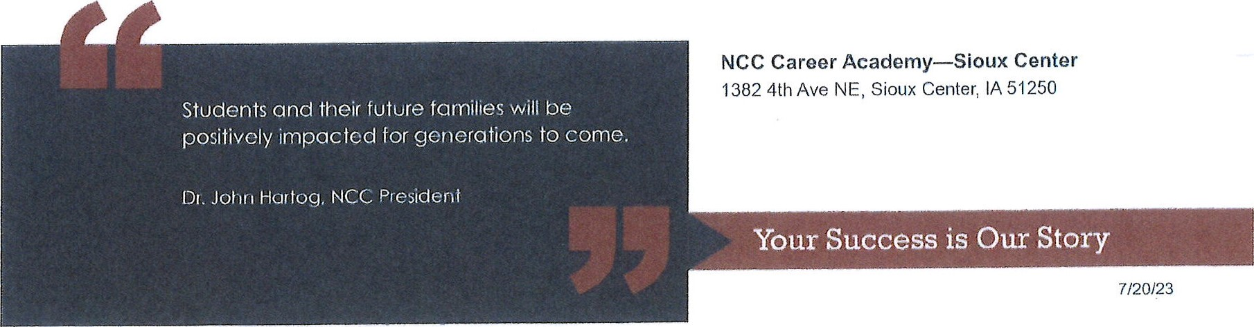

 |  |  |  | EDUCATION CAREER ACADEMY
 |  |  |  | Junior |  |  | Senior |  |  |  | After Graduation
Subject | Freshman | Sophomore |  | Fall | Spring |  | Fall | Spring
Language Arts | English I | English II |  | English III |  |  | ENG105 Composition I |  |  | Remaining Electives for TM in Early Childhood | Remaining Electives for  TM in Elementary Education | Remaining Electives for  TM in Secondary  Education
Math | Pre-Algebra or Algebra I | Algebra I or  Geometry |  | Algebra I or  Geometry | MAT110 Math for Liberal Arts |  |  |  |  | Science - 3 cr  Communications - 6 cr  Humanities - 3 cr  Math/Science/  Communications - 9 cr  Electives - 8 cr | EDU240- Educational  Psychology - 3cr  Science - 3cr  Communications - 6 cr  Humanities - 3 cr Social  Science/ Behavior  Sciences/  Math/Science/  Communications -3cr  Electives - 8 cr | Science - 3 cr  Communications- 6 cr  Humanities- 6 cr  Social  Science/Behavorial  Sciences- 3 cr  Math/Science/Commun ications/Humanities- 6  cr  Electives- 5 cr
Science | Physical Science | Life Science |  | Earth Science
Social Science | World History | World Cultures |  | US History |  |  | Government
PE & Health
CAREER CORE |  |  |  |  | HIS515 US History to 1877 |  | EDU235  Technology in the Classroom | EDU245  Exceptional  Learner
CAREER CORE |  |  |  | EDU235 Children's  Literature | EDU213  Introduction to  Education  (Elementary and  Secondary) |  |  | MAT117 Math for  Elementary  Teachers (EL  Pathway)
 |  |  |  | EDU210  Foundations of  Education | EDU150  Directed  Observation |  | EDU220  Human  Relations for the  Classroom  Teacher | PSY121  Developmental  Psychology
 |  |  | Paraeducator Certificate |  |  |  |  |  | AA Transfer Major awarded at Fall Graduation

MFG146 | MFG220
MFG429 | MFG455
Humanities | MFG548
Gen Ed | WEL265
Subject
Freshman
Sophomore
Fall
Spring
Fall
Spring
Fall
Spring
Language Arts
English I
English II
Interpersonal
Communications,
or other
communication
elective
CAD231
Math
Pre-algebra or
Algebra I
Algebra I or
geometry
MAT104 Applied
Math Topics
CAD246
Science

CAD248
Social Science
MFG325
PE & Health
CAD167
Intro to Parametric
Modeling
MFG185*
OSHA/Shop Safety
ATR102*
Introduction to
Robotics
MFG191*
MFG194*
Inspection
Processes
MFG122* Machine
Trade Printreading
MFG263
CAD 101
MFG150
Applied Math for
Manufacturing
MFG264
CAREER CORE
DESIGN TECHNOLOGY C
AREER
A
CADEMY
Junior
Senior
After Graduation
Engineering Design Certificate* | Towards Diploma | Towards Degree
*Subject to change, if changes made to programs

 | Health Careers CA
 |  |  | Junior |  | Senior
Subject | Freshman | Sophomore | Fall | Spring | Fall | Spring
Language Arts | English I | English II | English III
Math | Pre-algebra or Algebra I | Algebra I or Geomerty | Algebra I or Geometry | Math  for Liberal Arts*
Science | Physical Science | Biology | Chemistry | ENG105  Composition I* | BIO168 Anatomy & Physiology 1 w/lab* | BIO173 Anatomy & Physiology II w/lab*
Social Science | World History | World Cultures | US History |  | Government | PSY121 Developmental Psychology
PE & Health |  |  |  |  |  | PSY 111 Intro to Psychology
 |  |  | HSC113  Medical Terminology*  MWF 12:00-1:00 |  | Bio 151 Nutrition
 |  |  | HSC105  Intro to Health  Occupations MWF 1:15-2:00 | HSC 101 Emergency Care |  | Intro to Nursing
 | Students entering nursing at NCC are required to complete HSC171 Nurse Aid. Other HC programs encourage this coursework. |  | HSC171  Nurse Aid *
 | Following Junior year, students would be encouraged to choose between three different healthcare career pathways. They could choose Rad Tech and Nursing and just complete generals senior year (Comp I, Math,  A&P I, A&P II, Nurse Aid)*. They could choose the EMT/Paramedic pathway and take EMT Basic I & II along with A&P I and A&P II. They could also choose the Pharm Tech pathway and take Intro to Pharm Tech and Pharmacology and practicum and A&P I and A&P II. |  |  |  | EMS219  EMT Basic I | EMS225 EMT Basic II
CAREER CORE |  |  |  |  | PHR105 Introduction to Pharmacy Technician | PHR120 Pharmacology for Pharmacy Technician
 |  |  |  |  |  | PHR941 Pharmacy Technician Practicum
 | Successful completion of HSC172 prepares students to take the State of Iowa Certificed Nursing Assistant (CNA) exam. CNA course required for Nursing and Rad Tech program. |  |  | Students would be ready to enter PN Nursing at NCC after completing the Academy
 | Students completing PHR105, 120 and 941 are qualified to take the State of Iowa Pharmacy Technican Exam. |  |  | *Students would be ready to enter Radiological Technology at NCC after completing PSY 111 and other * courses.
 | Students completing EMT Basic I and Basic II would be able to take the NREMT Exam. |  |  | Students completing HSC101 Emergency Care would gain CPR and First Aid Certification. Intro to Health Occupations help students to decide on a path forward.

Nursing-8 hours a
ESTIMATED time 7 hours a week 7 hours a week
Nursing 9 hours a week

RAD Tech-5 hours a week
RAD Tech-8 hours a

Pharm Tech-3 hours Pharm Tech-6 hours a week-ONLINE a week
Summer
Fall
Spring
Summer
Fall
Spring
Summer
Fall
Spring
PNN659 Fundamentals
of Nursing
PNN670
Practical Nursing IA
RAD106
Foundations of
Radiologic Technology
RAD104
Radiologic Patient
Care
CSC110 Introduction
to Computers
BIO198 Introduction
to Pathology
PNN657
Nursing Concepts I
PNN671
Practical Nursing IA
Clinical
RAD122
Radiographic
Procedures I
RAD142
Radiographic
Procedures II
HIT370 Health Records
in Acute Care
HIT272 Medical Coding
II

PNN673
Practical Nursing IB
Preceprtor
RAD322
Imaging I
RAD230
Clinical Education II
HIS271 Medical Coding
I
HIT273 Medical Coding
III

PNN 650
Nursing Concepts IIA
RAD206
Clinical Education
RAD360
Imaging II
HIT209
Reimbursement
Methods

PN654
Nursing Concepts IIB
MAP141 Medical
Insurance

After Graduation for PN
After graduation for Medical Coding
Health Careers

continued after graduation
Requires 1 more year to complete RAD Tech Program and being
eligible to take the licensure exam.
Students will be ready to enter ADNprogram after completing PN and
passing nursing exam.
Students may decide to complete Associate degree in HIT after
completing Medical Coding diploma
After Graduation for RAD Tech
EMT- 6 hours a week EMT-6 hours a week

 |  |  | WELDING CAREER ACADEMY
 |  |  | Junior |  | Senior |  | After Graduation
Subject | Freshman | Sophomore | Fall | Spring | Fall | Spring | Summer | Fall
Language Arts | English I | English II | English III |  | SPC122
 |  |  |  |  | Interpersonal
 |  |  |  |  | Communications
 |  |  |  |  | (or other Communications)
Math | Pre-Algebra or Algebra I | Algebra I or  Geometry | Algebra I or  Geometry | MAT104
 |  |  |  | Applied Math
 |  |  |  | Topics
Science | Physical Science | Life Science | Earth Science
Social Science | World History | World Cultures | US History |  | Government
PE & Health |  |  |  |  |  |  |  | CAD167  Intro to Parametric Modeling
 |  |  | MFG185*  OSHA/Shop Safety  T/TH 8:30-9:30 |  | WEL120*  Oxy Fuedl Welding and Cutting | WEL191  Tungsten ARC  Welding | ATR102  Introduction to  Robotics | WEL308 Pipe Welding
CAREER CORE |  |  | MFG122*  Machine Trade  Printreading  T/TH 9:40-11:10 | WEL186*  GMAW |  | WEL187 Advanced GMAW |  | WEL206  Quality Assurance Program
 |  |  | MFG150  Applied Math for  Manufacturing |  | WEL200*  Metallurgy  Fundamentals | WEL320  Welding  Fabrication |  | WEL152  Shielded MetalARC Welding Lab
Production Welding Certificate* |  | Fall Graduate with Diploma in Production Welding
Engineering Design Certificate* | Towards Diploma | Towards Degree in Advanced Welding
 |  | continue into next sem
*Subject to change, if changes made to programs

6
/26/
23
NCC Career Academy—Sioux Center
1382 4
th Ave NE, Sioux Center, IA
51250
Students and their future families will be
positively impacted for generations to come.
Dr. John Hartog, NCC President
Your Success is Our Story
7
/20/
23

